Press Release

Ruggedized explosion-protected proximity switches with CSA approval for North America

EGE now also supplies the intrinsically safe inductive sensors IGEXa, IGEXHa, IGEXPa and IGEXUa as well as the evaluation device IKMb 122 Ex as versions certified according to CSA. The ruggedized proximity switches for metal detection are approved for use in zones 0 and 20 areas with potentially explosive atmospheres (HazLoc). They are available in M12, M18 and M30 standard designs. IGEXHa and IGEXPa are two sensors that withstand high-pressure cleaning and ambient temperatures up to 140 °C and down to -60 °C respectively. The corresponding IKMb 122 Ex evaluation device with a compact 22 mm wide DIN-rail housing for galvanic isolation and evaluation is installed in a control cabinet outside hazardous zones. Green, yellow and red LEDs on the housing front indicate the operating states of the connected proximity switch.

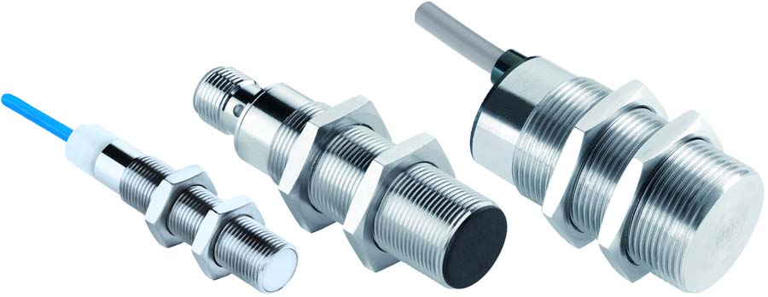
Bild: EGE now also supplies highly robust, intrinsically safe IGEX proximity switches with a CSA approval

Image/s: | igex_triple | Characters: | 829
File name: | 202206012_pm_igex_csa_approval_en | Date: | 09-08-2022
About EGE
EGE-Elektronik Spezial-Sensoren GmbH has been developing and manufacturing special purpose sensors for automation applications since 1976. The company serves leading international producers from a wide range of industries. Its product portfolio includes flow controllers, infrared, opto and ultrasonic sensors, capacitive proximity switches, light barriers and inductive proximity switches. EGE also provides sensors for highly sensitive applications, e.g. hazardous areas. The development department's highly qualified staff cooperates closely with all customers, ensuring continuous product updates and enhancement. A total of 130 employees, including 20 engineers and technicians, generate gross sales of approx. 19.5 million Euros worldwide.
Contact:  EGE-Elektronik Spezial-Sensoren GmbH  Sven-Eric Hiss  Ravensberg 34  24214 Gettorf  Germany  Phone: +49 . 4346 . 4158-0  Email: info@ege-elektronik.com  Internet: www.ege-elektronik.com |  | gii die Presse-Agentur GmbH  Immanuelkirchstr. 12  10405 Berlin  Germany  Phone: +49 . 30 . 538 9650  Email: info@gii.de  Internet: www.gii.de

