Press Release

Chain hoist configuration in 1 minute

An online configurator on the Liftket website leads to a tailor-made electric chain hoist in just a few steps. The straightforward tool instantly generates complete documentation with technical drawings. Customers as well as unregistered users can access this service and export the data as a PDF file. They can also request a quote, which will be emailed to them within minutes. They can place orders or a sales request referencing the quotation number. This unique ID enables sales staff to automatically access all configuration data, which helps to avoid errors. The configurator integrates all Liftket series. Various parameters can be freely defined or selected from standard measures: working load, lifting height, lifting speed, power supply specifications, type of suspension, and, if applicable, trolley type, trolley speed, and flange profile and width. This tool makes order placement for Liftket customers much faster and easier to handle in comparison to manually filling out conventional order forms. Managing and filing quotations is also greatly simplified. In addition, users can easily share quotes with other departments such as engineering and procurement.

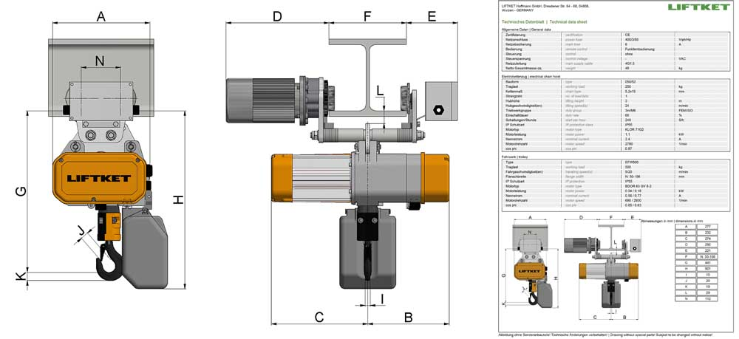
Illustration: Configuring an electric chain hoist requires no prior registration, takes only a few clicks, and leads directly to the technical documentation, including drawings

Illustrations: | liftket_configurator | Char’s: | 1177
File name: | 201902011_pm_liftket_configurator_en | Date: | 02-27-2019
About LIFTKET
LIFTKET Hoffmann GmbH is an internationally renowned manufacturer of electric chain hoists with loads ranging from 125 kg to 25,000 kg. At the company premises in Wurzen, Germany, currently about 280 employees develop and manufacture solutions for the three business segments industry, custom, and stage. A strong network of service and sales partners ensure customer-oriented stock-keeping, maintenance, and repair. LIFTKET manufactures modular electric chain hoists for virtually every application that involves the safe and precise lifting of loads. Founded in 1948 by Dietrich Hoffmann, the company initially developed agricultural equipment before specializing and exclusively focusing on electric chain hoists from 1953. Hoffmann's innovations, namely the horizontal assembly of motor and gearbox and the patented safety-brake/clutch system, still set the standard for electric chain hoists.

Reader contact:  LIFTKET Hoffmann GmbH  Dresdener Str. 64 – 68  04808 Wurzen  Germany  Phone: +49 3425 8924-0  Email: sales@liftket.de  Web: www.liftket.de | Press contact:  gii die Presse-Agentur GmbH  Immanuelkirchstr. 12  10405 Berlin  Germany  Phone: +49 30 538 965-0  Email: info@gii.de  Web: www.gii.de  LIFTKET Hoffmann GmbH  Marketing Department  Ulrike Veit  Dresdener Str. 64 – 68  04808 Wurzen  Germany  Phone: +49 3425 8924-87  Email: ulrike.veit@liftket.de  Web: www.liftket.de

