Press Release

SPS trade fair:
Noncontact temperature monitoring and soundchecks

Fluke Process Instruments will present its range of infrared temperature monitoring solutions for seamless integration in factory automation systems at the 2021 SPS trade fair in Nuremberg, Germany, at booth #7A-530, as well as its first acoustic imager. The manufacturer’s noncontact sensors and measuring systems are valuable tools for quality assurance, process optimization and 24/7 safety monitoring. They provide high flexibility with features such as remote setup and control, various connectivity and reporting options and user-defined automatic alarms. The SV600 Fixed Acoustic Imager detects gas leaks as well as mechanical faults and weaknesses in factory equipment or manufactured goods in real-time before they incur costly repairs and downtimes. Using an array of sophisticated sound sensors, a camera and powerful SoundMap technology, the SV600 visualizes sounds in order to help users quickly locate and evaluate potential problems.

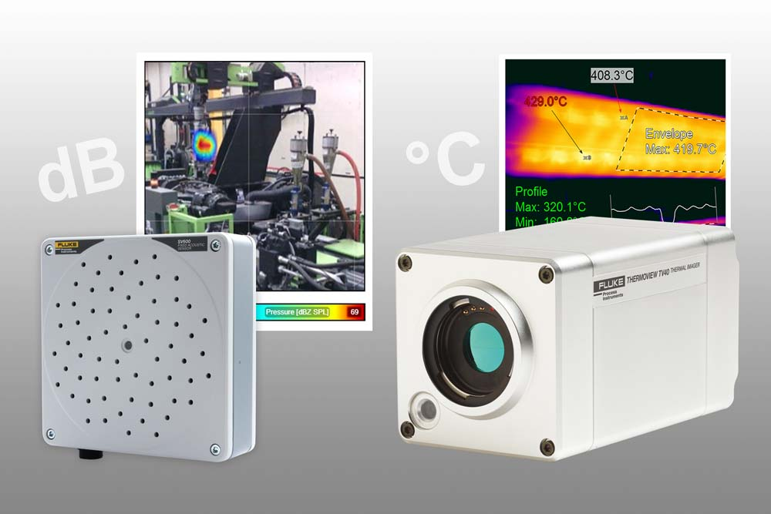
Caption: Acoustic and thermal imaging systems enable noncontact quality assurance, process optimization and 24/7 safety monitoring

Fixed-installation infrared measuring systems are used to monitor products and assets for overheating or defined irregularities. The ThermoView TV40 industrial-grade thermal imager has a temperature measurement range of -10 °C to 1200 °C. Featuring an integrated visible-light camera, it enables easy camera alignment and added detail on blended infrared and visual images. Users can define various areas of interest with distinct alarm conditions to ensure product quality, efficient fuel use, and proper functioning of machines and equipment. Various field-interchangeable lens options including wide-angle lenses are available. The Pan and Tilt enclosure, available as an accessory for the ThermoView TV40 thermal imaging camera, enables large-area monitoring for temperature irregularities. Another highlighted product line, the Raytek Compact MI3 pyrometer series, is designed especially for easy integration in plants and machines. The innovative multiple sensing head interface, which can support up to eight individually addressable heads per communication box, reduces sensor cost, simplifies sensor installation and applications troubleshooting, and provides the lowest cost per measurement point. Various spectral models for different temperature ranges and industrial applications are available. The series also comprises ATEX/IECEx-certified sensors.
Fluke Process Instruments at the SPS trade fair
Nuremberg, Germany, 23 – 25 November 2021
Hall 7A, Stand 530

Image/s: | sv600__tv40 | Characters: | 2311
File name: | 202110021_pm_sps_trade_fair_preview_en | Date: | 11-02-2021
About Fluke Process Instruments
Fluke Process Instruments designs, manufactures, and markets a complete line of infrared temperature measurement and profiling solutions for industrial, maintenance, and quality control applications. Distributed worldwide under the Raytek, Ircon, and Datapaq brands, the products reflect the combined experience of over 150 years in manufacturing the world’s finest temperature measurement tools and devices.
About Fluke
Founded in 1948, Fluke Corporation is the world leader in compact, professional electronic test tools. Fluke customers are technicians, engineers, electricians, and metrologists who install, troubleshoot, and manage industrial, electrical, and electronic equipment and calibration processes.
Contact:  Fluke Process Instruments GmbH  Blankenburger Str. 135  13127 Berlin  Germany  Phone: +49 . 30 . 478 008-0  Email: marketing@flukeprocessinstruments.de  Internet: www.flukeprocessinstruments.com |  | gii die Presse-Agentur GmbH  Immanuelkirchstr. 12  10405 Berlin  Germany  Phone: +49 . 30 . 538 965-0  Email: info@gii.de  Internet: www.gii.de

