Press Release

embedded world exhibition:
EMS, embedded ECUs, first touchscreen with force detection

HMI specialist RAFI presents its latest technologies at the 2019 embedded world exhibition in Nuremberg, Germany, Hall 3, Stand 541. The company's subsidiary RAFI ELTEC shows new applications and technologies from its EMS (Electronics Manufacturing Services) portfolio. RAFI's innovations include the TwinTouch touchscreen technology, which detects not only touch but also the intensity of pressure exerted on the panel. Combined touch and force detection prevents false inputs, increases operating security, and makes additional input levels feasible. Customized development of operating systems with capacitive touch displays is another RAFI highlight. Showcases in this segment include the Smart Pad 2.0 panel for Kuka robot systems as well as a premium-quality control panel for Schaerer coffee machines. Complementing these, RAFI also presents embedded control units. These ECUs can be used in operating solutions for various control and visualization tasks. This range has most recently been expanded by the Linux-based POWER-ECU control unit, which supports high-quality 3D visualizations as well as multi-touch inputs and full HD screen resolutions for displays up to 24".

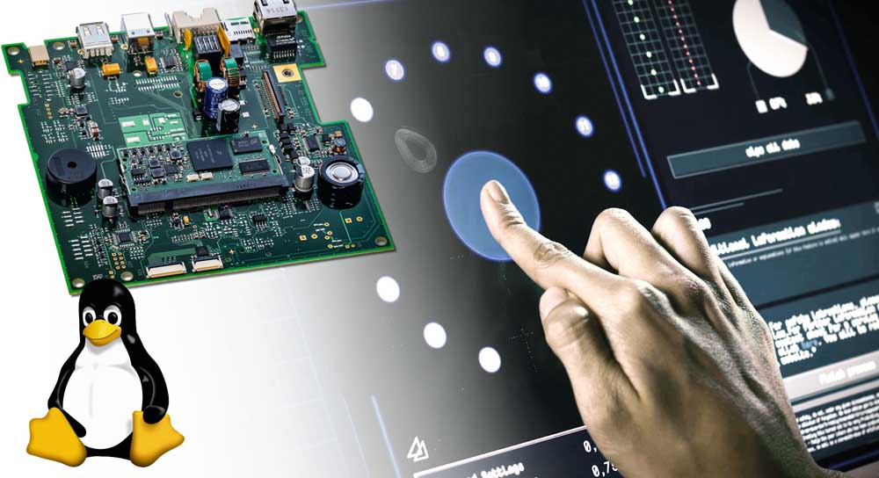
Illustration: The new TwinTouch input technology combines touch and force detection

EMS provider RAFI ELTEC develops and manufactures electronic assemblies and systems according to customer-specific requirements, starting from the idea all the way to the finished product. RAFI's subsidiary specializes in robust embedded wireless and controller solutions for all common transmission standards such as Wi-Fi, GSM-GPRS/UMTS/LTE, ZigBee, 6LowPan, LLC, Bluetooth, and other wireless technologies. The customized implementation of embedded control units is also part of RAFI ELTEC's scope of services.

Meet RAFI and RAFI ELTEC at the 2019 embedded world exhibition in Hall 3, Stand 541.

Illustrations: | rafi-embedded-19 | Char.s: | 1693
File name: | 201902001_pm_embedded_world_en | Date: | 02-06-2019
About RAFI
Founded in 1900, RAFI now develops and produces electromechanical components such as pushbuttons and switches, operating systems such as touch screens, keyboards, electronic components, and systems for man-machine communication. RAFI products are employed in more than 30 industries, e.g., in medical equipment, mechanical engineering, road and railway vehicles, household appliances, and telecommunications. The RAFI group operates internationally with approx. 2,500 employees at ten sites in Germany, Europe, China, and the USA. The group’s headquarters are located in Berg (Baden-Württemberg, Germany).

Contact:  RAFI GmbH & Co. KG  Artur Krug  Ravensburger Str. 128-134  88276 Berg  Germany  Tel.: +49 . 751 . 891 307  Fax: +49 . 751 . 891 300  e-mail: artur.krug@rafi.de  WWW: www.rafi.de |  | gii die Presse-Agentur GmbH  Immanuelkirchstr. 12  10405 Berlin  Germany  Tel.: +49 . 30 . 5389 650  Fax: +49 . 30 . 5389 6529  email: info@gii.de  Internet: www.gii.de

