Press Release

Foundation stone ceremony for new motor plant of Menzel Elektromotoren

Menzel Elektromotoren launched the construction work for its new plant in Hennigsdorf on the outskirts of Berlin with the laying of the foundation stone on 11 June 2022. More than 200 guests and employees attended the celebrations. The new, purpose-built headquarters will be erected on a 24,000 m² plot. All administrative and production workplaces are to be relocated by January 2024. When complete, the new motor plant with an effective floor space of 8,500 m² will increase the manufacturer's production capacities, allow the expansion of the workforce and earn significant efficiency gains through an optimized floor plan. The production area of about 3,800 m² will accommodate the assembly, metal processing, fabrication and winding workshops, paint shops and three state-of-the-art test fields. In addition, there will be roomy offices, logistics zones and storage areas. The spacious property allows for future expansions and is easy to reach via public transport, motorway or the Berlin Brandenburg International Airport.

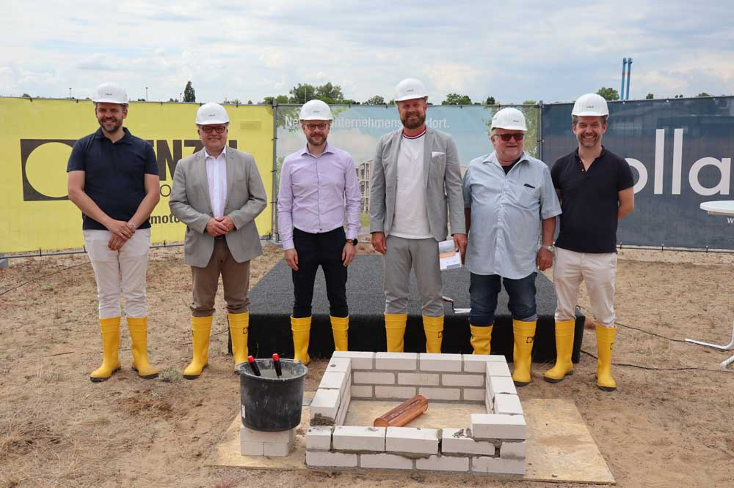
Caption: Foundation stone ceremony for the new Menzel plant with the project manager
Paul Bernhardt, Thomas Günther, mayor of Hennigsdorf, Mathias Jordt from the general contractor Vollack and the management: Mathis Menzel, Kurt Menzel and Dirk Achhammer (left to right)

The move heralds a new era for the motor company, which was founded in 1927. Under the management of Mathis Menzel, who runs the family business in the third generation, Menzel has experienced significant growth in recent years. The new building allows for a streamlined and ergonomic layout for all production processes and thus a higher throughput. Crane capacities will be significantly increased in order to meet the demand for ever larger motor systems from customers in all industries. Menzel manufactures three-phase asynchronous motors with squirrel cage or slip ring rotors up to 20 MW and DC motors up to 2 MW. Menzel offers several powerful own-brand motor series and is also specialized in customization as well as identical replication of existing motors. Menzel keeps various motor versions up to 15 MW permanently in stock and adapts them at short notice for a wide variety of applications and locations. Furthermore, the company offers comprehensive testing services for electric motors, generators, transformer-converter-motor systems, gearboxes and frequency converters, idle tests up to 10 MW, load tests up to 1.8 MW and multi-frequency heat load testing up to 5 MW. The new test fields will be larger, too, to allow for future expansions of the company’s testing services.
Updates on building phases: https://www.menzel-motors.com/news/

Image/s: | menzel_foundation_stone |  | Characters: | 2323
File name: | 202206021_pm_new_plant_foundation_stone_en |  | Date: | 06-13-2022
About Menzel Elektromotoren
Based in Berlin, Menzel Elektromotoren GmbH has been manufacturing and distributing electric motors since 1927. The medium-sized company specializes in the delivery of large electric motors, including special models, within the shortest possible time. The product range comprises high and low voltage motors, DC motors, transformers, and frequency inverters. Services include motor production and short-term adaptation of stocked motors to application-specific requirements. In order to ensure fast deliveries to the customer at all times, the company maintains a very extensive inventory including more than 20,000 motors with a maximum performance of up to 15,000 kW. Qualified engineering, experienced staff, and state-of-the-art production and testing facilities help Menzel provide excellent reliability. Menzel operates subsidiaries in the UK, France, Italy, Spain, and Sweden, and cooperates with numerous partners worldwide.
Contact:  Menzel Elektromotoren GmbH  Mathis Menzel  Neues Ufer 19 – 25  10553 Berlin  Germany  Phone: +49 . 30 . 349 922-0  Email: info@menzel-motors.com  Internet: www.menzel-motors.com |  | gii die Presse-Agentur GmbH  Immanuelkirchstr. 12  10405 Berlin  Germany  Phone: +49 . 30 . 538 9650  Email: info@gii.de  Internet: www.gii.de

