Press Release

Boosting glass vial and syringe production

Fluke Process Instruments offers powerful sensing tools for glass vial and syringe production that allow manufacturers to ramp up production while ensuring consistent high product quality. Processes need to be optimized for high throughput and productivity now that the COVID-19 vaccination drive increases the demand for medical glass products. Fluke Process Instruments supports the medical glass industry in establishing application-specific temperature monitoring solutions that provide the comprehensive, accurate, and traceable data needed. The company manufactures data loggers and non-contact infrared sensors and advises customers on the correct choice and configuration for processes such as gob forming, glass pre-heating, shrinking, flanging, forming, cutting, annealing stress testing, and more. Fluke Process Instruments is a leading international manufacturer of industrial temperature measurement systems.

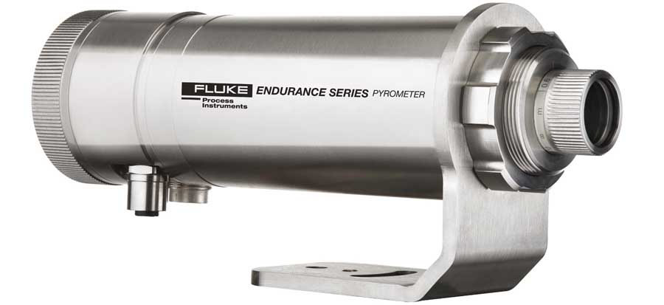
Caption 1: Temperature measurement solutions from Fluke Process Instruments allow the medical glass industry to optimize processes and boost their productivity (pictured: Endurance series spot pyrometer for non-contact infrared measurement)

Spot pyrometers are a non-contact solution used to monitor temperatures both in moving lines and stationary processes. There are specialized wavelength models for measuring glass, and the Marathon MM, Endurance, and Thermalert 4.0 series provide options for very cost-sensitive applications as well as for the most advanced requirements. In addition, the ThermoView TV40 thermal imager is available for continuous monitoring of forming and sealing processes. Complementing the infrared pyrometry portfolio, the Datapaq Furnace Tracker line features high-temperature through-process profiling technology based on a data logger and thermal barrier. These systems measure the temperature of the products as they pass through the furnace via short thermocouples attached to the glass. The accompanying software facilitates process control, optimization, and validation.
More information: https://get.flukeprocessinstruments.com/glassvials/directindustry/eblast/

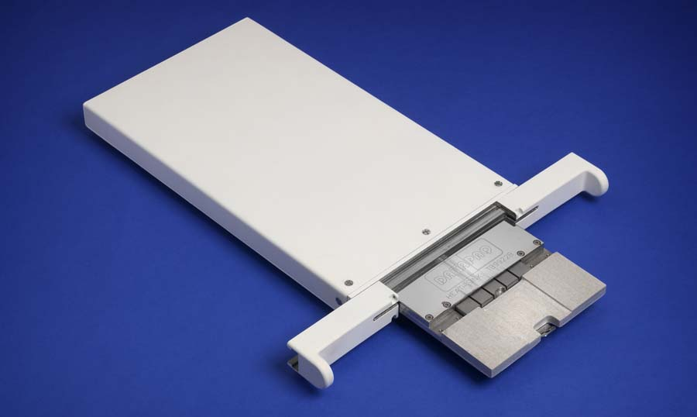
Caption 2: Datapaq Furnace Tracker systems featuring rugged data loggers record full temperature profiles inside the furnace

Image/s: | endurance_phase2_rside  datapaq_furnace_tracker_low-height_tb | Characters: | 1786
File name: | 202101006_pm_glass_vials_and_syringes_en | Date: | 02-10-2021
About Fluke Process Instruments
Fluke Process Instruments designs, manufactures, and markets a complete line of infrared temperature measurement and profiling solutions for industrial, maintenance, and quality control applications. Distributed worldwide under the Raytek, Ircon, and Datapaq brands, the products reflect the combined experience of over 150 years in manufacturing the world’s finest temperature measurement tools and devices.
About Fluke
Founded in 1948, Fluke Corporation is the world leader in compact, professional electronic test tools. Fluke customers are technicians, engineers, electricians, and metrologists who install, troubleshoot, and manage industrial, electrical, and electronic equipment and calibration processes.

Contact:  Fluke Process Instruments GmbH  Leonardo Trame  Blankenburger Str. 135  13127 Berlin  Germany  Phone: +49 . 30 . 478 008-0  Email: marketing@flukeprocessinstruments.de  Internet: www.flukeprocessinstruments.com | gii die Presse-Agentur GmbH  Immanuelkirchstr. 12  10405 Berlin  Germany  Phone: +49 . 30 . 538 965-0  Email: info@gii.de  Internet: www.gii.de

