Press Release

Powerful Linux control unit for RAFI touch operating panels

RAFI offers customization of its GLASSCAPE touch displays and control panels with complete processor units for control and visualization tasks. Using its own embedded control units (ECU), the HMI specialist ensures the time-saving and efficient implementation of customer projects in industrial, automotive, and medical applications. Device manufacturers thus receive complete, ready-to-install touch control solutions including housings and drivers from a single source. Three performance classes cover the entire range of requirements: the ECO-ECU series offers cost-optimized solutions for simple control and display tasks. BALANCE-ECU units support touch displays with resolutions up to 800 x 600 pixels and are suitable for displaying animated graphics. The most powerful unit, POWER-ECU, supports high-quality 3D visualizations, multitouch input, and full HD screen resolution for display diagonals up to 24". The necessary computing power comes from the integrated ARM Cortex-A9 clocked at 800 MHz, complemented by 1 GByte DDR3 SDRAM and 1 GByte NAND flash memory.

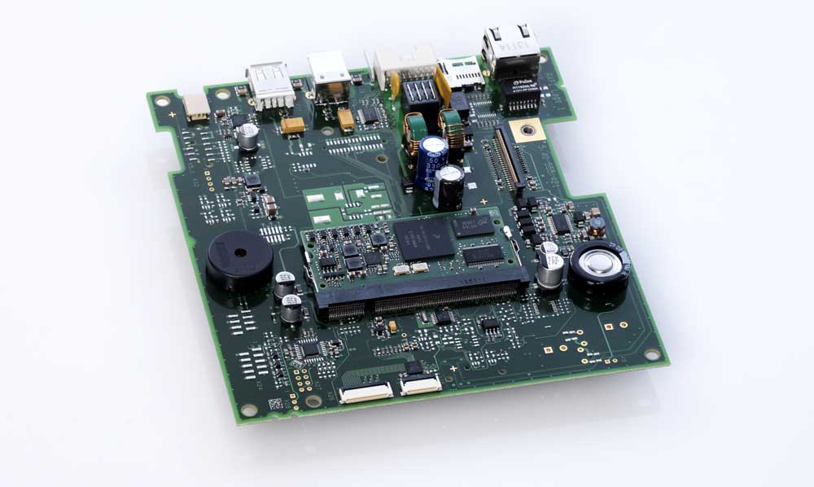
Caption: POWER-ECU from RAFI, integrated in customer-specific electronics

The long-lasting POWER-ECUs are now also available with a Yocto-based embedded Linux operating system as an alternative to Windows Embedded Compact 2013 or 7. Users benefit from optimized hardware controls, secure integration of control systems into their own applications, and RAFI's commitment to provide tweaks and continuous software maintenance. In addition, the inherent advantages of the Linux environment include transparency and ongoing development of the kernel by a global community. The POWER-ECU units are designed as plug-in modules for a baseboard with a scalable periphery, supplied by RAFI with custom form factor, customer-specified interfaces, and all necessary drivers. RAFI also offers POWER-ECU evaluation kits for customers seeking to develop their own applications.

Image/s: | power-ecu | Characters: | 1860
File name: | 201903026_pm_linux_power-ecu_en | Date: | 10-09-2019
About RAFI
Founded in 1900, RAFI now develops and produces electromechanical components such as pushbuttons and switches, operating systems such as touch screens, keyboards, electronic components, and systems for man-machine communication. RAFI products are employed in more than 30 industries, e.g., in medical equipment, mechanical engineering, road and railway vehicles, household appliances, and telecommunications. The RAFI group operates internationally with approx. 2,500 employees at ten sites in Germany, Europe, China, and the USA. The group’s headquarters are located in Berg (Baden-Württemberg, Germany).

Contact:  RAFI GmbH & Co. KG  Artur Krug  Ravensburger Str. 128-134  88276 Berg  Germany  Phone: +49 . 751 . 891 307  Fax: +49 . 751 . 891 300  Email: artur.krug@rafi.de  Internet: www.rafi.de | gii die Presse-Agentur GmbH  Immanuelkirchstr. 12  10405 Berlin  Germany  Phone: +49 . 30 . 5389 650  Fax: +49 . 30 . 5389 6529  Email: info@gii.de  Internet: www.gii.de

