Press Release

ITE2019: Largest variety of MIPI camera modules & quad-core embedded vision

At the ITE2019 show in Yokohama, Japan, Vision Components presents its extended range of high-end camera modules with a MIPI CSI-2 interface: now offering 10 different image sensors with resolutions up to 13 MP, the German manufacturer leads the global market for MIPI camera boards. These high-tech components enable compact, repeatable OEM designs and easy connection of image sensors to more than 20 single-board computers, including NVIDIA Jetson, DragonBoard, all Raspberry Pi boards, and all 96Boards. ITE2019 showcases include a demo application with a VC MIPI camera module connected to a Raspberry Pi 4 Model B. Vision Components supplies large numbers of MIPI boards at consumer prices. The accompanying VC MIPI cables support high data rates.

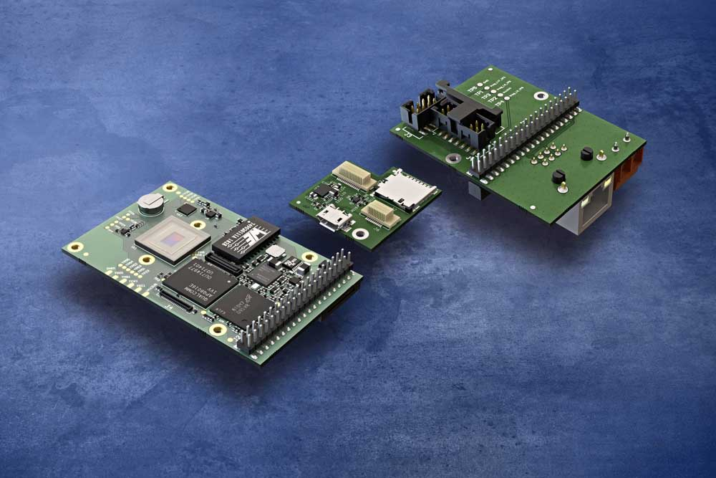
Caption: New embedded cameras with a quad-core CPU can be extended by boards featuring SD card slots and various interfaces

The manufacturer’s Linux-based, freely programmable embedded vision systems are also on display. Integrating a Xilinx Zynq SoC, these cameras and 3D line sensors autonomously carry out all kinds of image processing tasks. Their long-term availability guaranteed, they are a safe choice for industrial serial applications. The latest-generation VCnano3D-Z laser profiler features VC's proprietary ambient light suppression technology, which enables operation under up to 100,000 lux. The onboard FPGA calculates the 3D point cloud. The ARM processor can be programmed for further jobs like analyzing the grayscale image. Brand-new quad-core embedded cameras provide a substantial performance boost due to the onboard Snapdragon 410 processor: 1.2 GHz clock rate, 1 GB RAM, 16 GB flash memory. In addition to various built-in interfaces like GigE and 12 GPIOs, this board camera is available with optional extension boards that enable easy, flexible addition of an SD card slot and more interfaces: serial interface, I²C, RS232, DSI, RJ45 Ethernet adapter, and power interface.
Interested parties are invited to stop by the booth and discuss their vision application with the team. This industry event requires no advance registration. Admission is free.
Vision Components at ITE2019
International Technical Exhibition on Image Technology and Equipment
Japan, PACIFICO Yokohama convention center, 4 – 6 December 2019
Booth #51 with Tokyo Machine Vision
Booth #65 with MI TECH

Image/s: | quad-core_vc_cam__sd_card__interface_board | Characters: | 2004
File name: | 201911019_pm_ite_yokohama_en | Date: | 11-21-2019
About Vision Components
Vision Components is a leading international manufacturer of embedded vision systems. The freely programmable cameras with powerful onboard CPUs perform image processing tasks on their own without the need for an additional computer. Vision Components offers OEMs versatile Linux-based embedded systems for 2D and 3D image processing, supplied as board cameras or in protective casings. These are complemented by a growing range of ultracompact MIPI camera boards, which connect to a variety of different CPU boards. In addition, Vision Components offers software libraries and develops customized solutions on request. The team of experts can draw on extensive knowledge and over 20 years of experience with imaging applications. The company based in Ettlingen in southwestern Germany was founded in 1996 by Michael Engel, the inventor of the first industrial-grade intelligent camera. More world premieres followed, including the world's first intelligent vision sensors and the first-ever embedded 3D laser profiler. Today, Vision Components has sales offices in the United States and Japan and works with local partners in over 25 countries to provide consistent customer focus and readily available expertise throughout the world.

Contact:  Vision Components GmbH  Miriam Schreiber  Ottostr. 2  76275 Ettlingen  Germany  Phone: +49 . 7243 . 216 716  Email: miriam.schreiber@vision-components.com  Internet: www.vision-components.com | gii die Presse-Agentur GmbH  Immanuelkirchstr. 12  10405 Berlin  Germany  Phone: +49 . 30 . 538 9650  Email: info@gii.de  Internet: www.gii.de

