Press Release

Dynamic flow sensor for detecting microdoses

EGE designed its dynamic SDN 501/1 GSP-DYN flow controller to detect minimal pulsating flow rates from 0.02 ml. Suitable for most common liquids such as water, alcohol, oils, and fluid greases, the flow sensor is ideal for monitoring minimum lubrication or ensuring that the right amounts of chemicals or additives are metered out. Since the sensor operates according to the thermodynamic principle, it does not have any moving or corrosion-prone wear-and-tear parts. Due to its high sensitivity, it reacts to changing flow rates – caused for example by the actuation of a dosing piston – with extremely short reaction times of 0.1 s. The sensor's built-in processing unit emits a switching signal for each detected pulse via a short-circuit-proof PNP-NO output and can hold the signal for up to 10 s. In addition, green and yellow LEDs on the housing front signal the detected pulses and the current device status. Manufactured from stainless steel and PBT, the robust sensors feature IP54 ingress protection and withstand pressures up to 10 bar. They are suitable for media temperatures between 0 °C and 80 °C. The units are operated with 24 VDC. They are fitted into pipes via a tube fitting or a G¼ thread and connected by means of an M12 connector. Mounting angles are available as accessories. The flow controllers' compact design enables parallel installation of several devices with different monitoring functions.

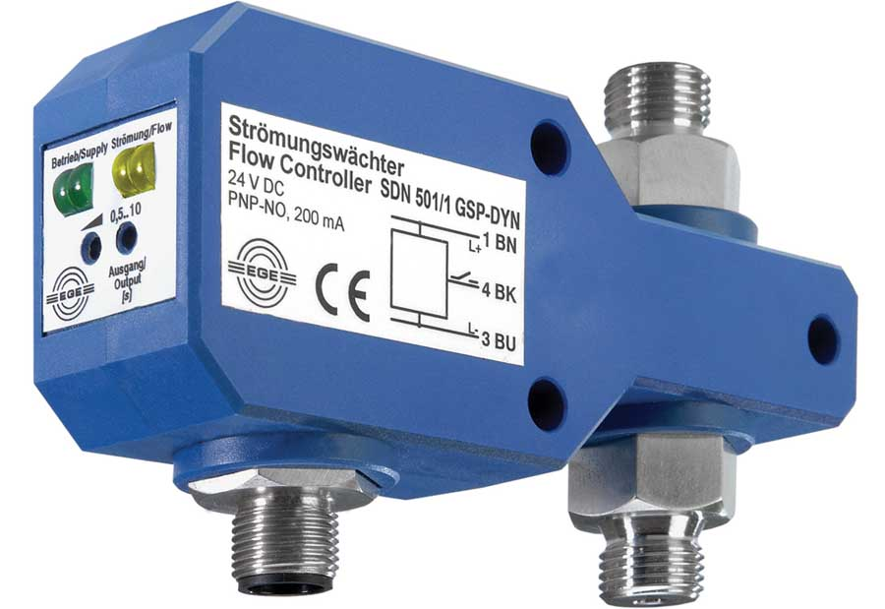
Caption: The dynamic SDN 501/1 GSP-DYN flow controller detects pulsating flow rates from 0.02 ml

Image/s: | SDN 501_1 GSP-DYN | Characters: | 1422
File name: | 201911034_pm_sdn_501_flow_sensor_en | Date: | 03-04-2020
About EGE
EGE-Elektronik Spezial-Sensoren GmbH has been developing and manufacturing special purpose sensors for automation applications since 1976. The company serves leading international producers from a wide range of industries. Its product portfolio includes flow controllers, infrared, opto and ultrasonic sensors, capacitive proximity switches, light barriers and inductive proximity switches. EGE also provides sensors for highly sensitive applications, e.g. hazardous areas. The development department's highly qualified staff cooperates closely with all customers, ensuring continuous product updates and enhancement. A total of 89 employees, including 20 engineers and technicians, generate gross sales of approx. 19.5 million Euros worldwide.

Contact:  EGE-Elektronik Spezial-Sensoren GmbH  Sven-Eric Hiss  Ravensberg 34  24214 Gettorf  Germany  Phone: +49 . 4346 . 4158-0  Fax: +49 . 4346 . 5658  Email: info@ege-elektronik.com  Internet: www.ege-elektronik.com | gii die Presse-Agentur GmbH  Immanuelkirchstr. 12  10405 Berlin  Germany  Phone: +49 . 30 . 538 965-0  Fax: +49 . 30 . 538 965-29  Email: info@gii.de  Internet: www.gii.de

