Press Release

ATEX-certified flow monitors for zones 2 and 22

The new ATEX-certified airflow monitors from the LC 518 GSP-EX22 series from EGE are used for flow monitoring of gaseous media in exhaust and supply air lines that require category 3 sensors. The stainless-steel sensors are designed for a 0.5 m/s to 20 m/s detection range. In applications with a specified air flow, users can easily adjust the limit value during operation via an onboard potentiometer. The flow state is indicated by a three-color light on the housing front and transmitted for further processing by a PNP switching output. When the limit value is exceeded, the light changes from red to yellow, a further increase in the flow velocity is signaled by a green light. The 80 mm long sensors are mounted directly in the wall of the ventilation duct with mounting nuts included in the scope of delivery. The M18 thread, which runs over the entire length of the housing, allows optimal positioning at different wall thicknesses. If the airflow is sufficient in the edge area, the measuring surface can be installed on a level with the inner wall of the duct. The sensors are designed in protection class IP67 and connected via a 2 m long PUR cable.

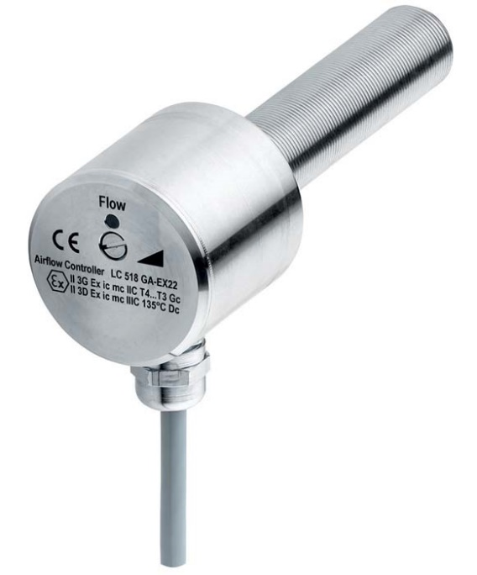
Bild: LC 518 GSP-EX22 airflow monitor for zone 2 and 22 hazardous areas

Image/s: | LC_518_GSP-EX22 | Characters: | 1161
File name: | 202206009_pm_airflow_monitors_lc_518_gsp-ex22_en | Date: | 07-20-2022
About EGE
EGE-Elektronik Spezial-Sensoren GmbH has been developing and manufacturing special purpose sensors for automation applications since 1976. The company serves leading international producers from a wide range of industries. Its product portfolio includes flow controllers, infrared, opto and ultrasonic sensors, capacitive proximity switches, light barriers and inductive proximity switches. EGE also provides sensors for highly sensitive applications, e.g. hazardous areas. The development department's highly qualified staff cooperates closely with all customers, ensuring continuous product updates and enhancement. A total of 130 employees, including 20 engineers and technicians, generate gross sales of approx. 19.5 million Euros worldwide.
Contact:  EGE-Elektronik Spezial-Sensoren GmbH  Sven-Eric Hiss  Ravensberg 34  24214 Gettorf  Germany  Phone: +49 . 4346 . 4158-0  Email: info@ege-elektronik.com  Internet: www.ege-elektronik.com |  | gii die Presse-Agentur GmbH  Immanuelkirchstr. 12  10405 Berlin  Germany  Phone: +49 . 30 . 538 9650  Email: info@gii.de  Internet: www.gii.de

