Press Release

glasstec trade fair:
Temperature monitoring solutions for QA in glass production

Fluke Process Instruments will showcase temperature monitoring solutions for quality control in glass manufacturing, forming and coating processes at the glasstec trade fair in Düsseldorf, Germany (Booth 14-A41). The lineup features various infrared sensors and thermal imaging systems for non-contact temperature measurement and analysis. Real-time feedback and comprehensive connectivity options ensure easy integration in factory control systems. Line operators receive real-time process information to help them increase plant productivity, improve ROI and minimize operating costs. The MP Linescanner series provides live thermal imaging of moving processes such as float glass manufacturing and flat glass tempering, checking for temperature uniformity as well as physical damage and detecting hot spots and cold spots. For monitoring the temperature curve inside the furnace, Datapaq dataloggers are available, which track temperatures via thermocouples attached to the glass sheet surface. The manufacturer furthermore offers a full range of infrared pyrometers with suitable wavelengths for all kinds of applications in the manufacture of bottles, vials, ultra-thin drawn glass for touchscreens and much more.
Fluke Process Instruments at glasstec
Düsseldorf, Germany, 20 – 23 September 2022
Hall 14, Stand A41

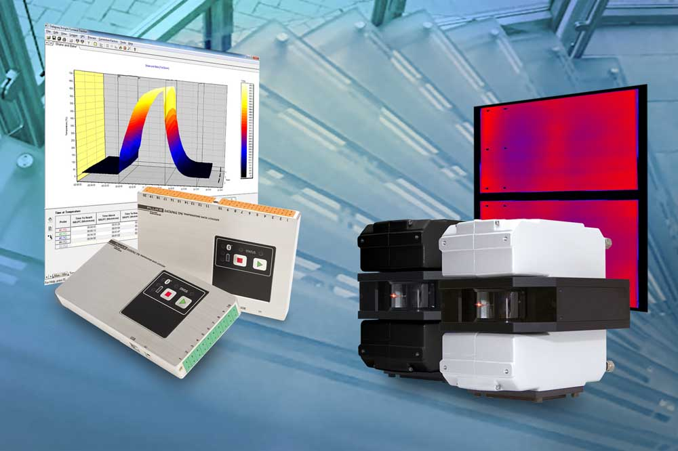
Caption: Fluke Process Instruments offers temperature profiling systems and thermal imagers for all kinds of glass manufacturing processes

Image/s: | tp6_and_linescanners_for_glass | Characters: | 1218
File name: | 202208014_pm_glasstec_en | Date: | 08-25-2022
About Fluke Process Instruments
Fluke Process Instruments designs, manufactures, and markets a complete line of infrared temperature measurement and profiling solutions for industrial, maintenance, and quality control applications. Distributed worldwide under the Raytek, Ircon, and Datapaq brands, the products reflect the combined experience of over 150 years in manufacturing the world’s finest temperature measurement tools and devices.
About Fluke
Founded in 1948, Fluke Corporation is the world leader in compact, professional electronic test tools. Fluke customers are technicians, engineers, electricians, and metrologists who install, troubleshoot, and manage industrial, electrical, and electronic equipment and calibration processes.
Contact:  Fluke Process Instruments GmbH  Blankenburger Str. 135  13127 Berlin  Germany  Phone: +49 . 30 . 478 008-0  Email: marketing@flukeprocessinstruments.de  Internet: www.flukeprocessinstruments.com |  | gii die Presse-Agentur GmbH  Immanuelkirchstr. 12  10405 Berlin  Germany  Phone: +49 . 30 . 538 9650  Email: info@gii.de  Internet: www.gii.de

