Press Release

Ex-certified proximity switches for extreme ambient temperatures

The intrinsically safe ATEX- and IECEx-certified proximity switches from EGE's IGEXHa and IGEXPa series are suitable for use at extreme temperatures. IGEXHa inductive sensors withstand ambient temperatures of up to +140 °C. IGEXPa "polar" models are suitable for down to -60 °C. Both series are approved for operation in zones 0/20. They feature IP69 ingress protection and are available in M12, M18, and M30 designs. Given a flush installation, the nominal switching distances are 2 mm, 5 mm, and 10 mm, depending on the design. The proximity switches are connected via a 2 m FEP cable. EGE supplies the sensors with different cable lengths on request. EGE also offers the IKMb 122 Ex series of suitable IECEx-certified signal processing units and intrinsically safe power supplies with programmable outputs. Internationally active machine builders benefit from the IECEx certification since it facilitates exporting products that integrate these proximity switches.

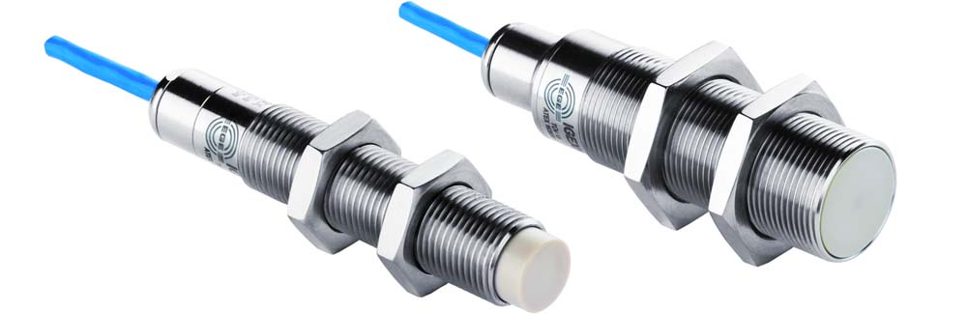
Illustration: EGE offers intrinsically safe ATEX/IECEx zone 0/20 proximity switches for extreme ambient temperatures with three thread sizes

Illustrations: | igexh_gruppe | Char.s: | 967
File name: | 201903044_pm_igex_proximity_switches_en | Date: | 05-15-2019
About EGE
EGE-Elektronik Spezial-Sensoren GmbH has been developing and manufacturing special purpose sensors for automation applications since 1976. The company serves leading international producers from a wide range of industries. Its product portfolio includes flow controllers, infrared, opto and ultrasonic sensors, capacitive proximity switches, light barriers and inductive proximity switches. EGE also provides sensors for highly sensitive applications, e.g. hazardous areas. The development department's highly qualified staff cooperates closely with all customers, ensuring continuous product updates and enhancement. A total of 89 employees, including 20 engineers and technicians, generate gross sales of approx. 19.5 million Euros worldwide.

Contact:  EGE-Elektronik Spezial-Sensoren GmbH  Sven-Eric Hiss  Ravensberg 34  24214 Gettorf  Germany  Phone: +49 . 4346 . 4158-0  Fax: +49 . 4346 . 5658  Email: info@ege-elektronik.com  Internet: www.ege-elektronik.com | gii die Presse-Agentur GmbH  Immanuelkirchstr. 12  10405 Berlin  Germany  Phone: +49 . 30 . 538 965-0  Fax: +49 . 30 . 538 965-29  Email: info@gii.de  Internet: www.gii.de

