Press Release

KDS/KES-VS sealing plugs

CONTA-CLIP expands its range of accessories for the KDS and KES cable management systems, adding sealing plugs. The KDS/KES-VS plugs have a mushroom head that prevents complete insertion and allows for easy removal. They are available in diameters between 1.5 mm and 22 mm. The sealing plugs provide flexible and reliable sealing of feedthrough channels according to protection degree IP66. Their protruding edge provides additional protection against splashing water and dust. The plugs can be used to quickly seal KES openings that have been perforated; and they allow for pre-configuration of KDS sealing elements for cable assemblies that can be completed at a later point.
CONTA-CLIP's KDS and KES systems enable tool-less configuration of cable and conduit feedthroughs and entries, as well as subsequent changes without compromising the ingress protection degree.

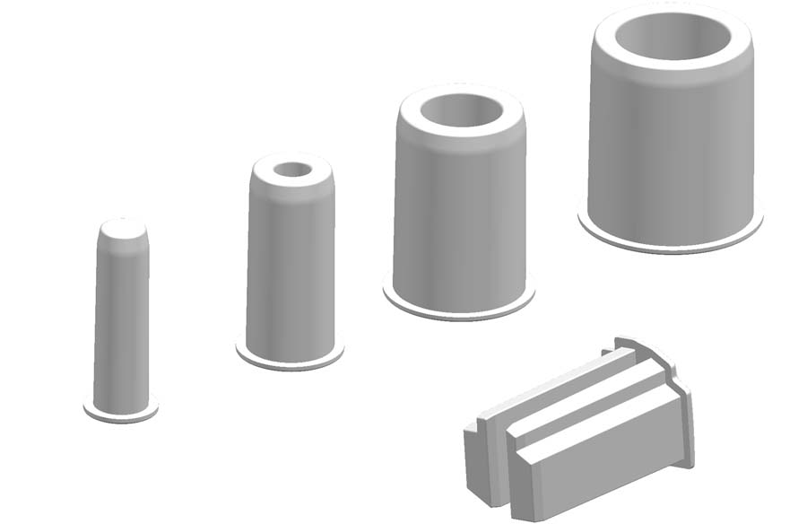
Caption: The mushroom head of the KDS/KES-VS sealing plugs prevents their being inserted too deep and lets them easily be removed

Image/s: | KDS_KES_VS-Uebersicht | Characters: | 869
File name: | 201912013_pm_kds-kes-vs_sealing_plugs_en | Date: | 02-19-2020
About CONTA-CLIP
CONTA-CLIP is one of Europe’s leading manufacturers of electrical and electronic connection elements and cable management solutions. Based in Hövelhof, Germany, the medium-sized, family-run company has been producing electric and electronic connection systems for the process and automation industries for 40 years. CONTA-CLIP supplies all industry sectors, focusing on railroad industries, shipbuilding, building automation, conveyor technology, machine and plant engineering and construction, instrumentation and control technology, control panel manufacturing, transformer manufacturing, and environmental technology. The company consists of many specialized branches: CONTA-CONNECT for electric connection technology, CONTA-CABLE for cable management systems, CONTA-ELECTRONICS for electronics and CONTA-CON for PCB edge connectors. Additionally, CONTA-CLIP provides services such as customizing housings and mounting rails, labeling and supplying user-specific electronic components.

Contact:  CONTA-CLIP  Verbindungstechnik GmbH  Christian Quade  Otto-Hahn-Str. 7  33161 Hövelhof  Germany  Phone: +49 . 5257 . 9833 - 0  Fax: +49 . 5257 . 9833 - 33  Email: christian.quade@conta-clip.de  Internet: www.conta-clip.com | gii die Presse-Agentur GmbH  Immanuelkirchstr. 12  10405 Berlin  Germany  Phone: +49 . 30 . 538 965 - 0  Fax: +49 . 30 . 538 965 - 29  Email: info@gii.de  Internet: www.gii.de

