Press Release

High-powered dual-speed medium voltage motors

Berlin-based Menzel Elektromotoren is one of the few manufacturers of large dual-speed or pole-changing low and medium voltage motors today. This motor type can propel fans, pumps, hoists, and other machines at two different speeds without a frequency inverter – a cost-saving solution for applications requiring only two speeds that moreover reduces the risk of failure. Typically, these motors are designed for an operating speed and a slower speed to facilitate startup. Dual-speed designs of large motors have become a rare exception. However, the family-run company Menzel continues to offer this option. In a current project, the end customer had explicitly specified pole-changing motors. To implement the particular speed ratios, Menzel manufactured three-phase asynchronous motors with two independent stator windings, a 6-pole and an 8-pole winding combined in one housing. The motors intended to power fans in a cement plant have a rated voltage of 6000 V with rated operating speeds of 988 min⁻¹ and 746 min⁻¹ at rated outputs of 850 kW and 500 kW respectively. As another special feature, these customized motors withstand ambient temperatures from -38 °C to 40 °C. Menzel, a motor manufacturer serving customers worldwide, individually assesses requests for larger low and medium voltage motors for optimum feasibility whilst supporting customers in choosing the right solution.
Additional references as well as contact details for specialized technical staff can be found at https://www.menzel-motors.com/article/dual-speed-motors/.
Hannover Messe: Hall 5, Stand C36

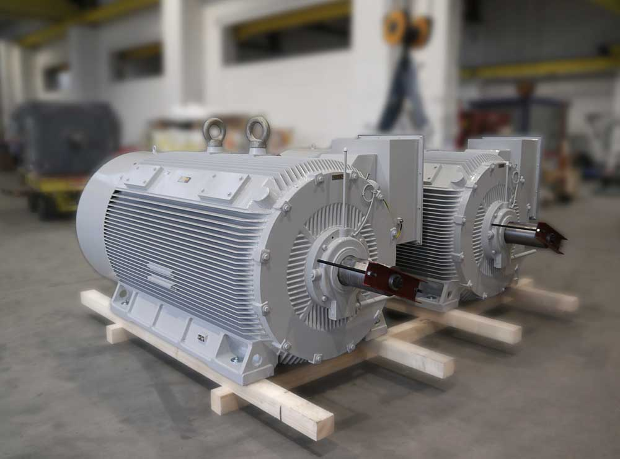
Caption: Menzel built two dual-speed motors with a rated voltage of 6000 V for a venting system

Image/s: | dual-speed_fan_motors_cement | Characters: | 1546
File name: | 202002020_pm_dual-speed_motors_en | Date: | 02-26-2020
About Menzel Elektromotoren
Based in Berlin, Menzel Elektromotoren GmbH has been manufacturing and distributing electric motors for more than 90 years. The medium-sized company specializes in the delivery of large electric motors, including special models, within the shortest possible time. The product range comprises high and low voltage motors, DC motors, transformers, and frequency inverters. Services include motor production and short-term adaptation of stocked motors to application-specific requirements. In order to ensure fast deliveries to the customer at all times, the company maintains a very extensive inventory including more than 20,000 motors with a maximum performance of up to 15,000 kW. Qualified engineering, experienced staff, and state-of-the-art production and testing facilities help Menzel provide excellent reliability. Menzel operates subsidiaries in the UK, France, Italy, Spain, and Sweden, and cooperates with numerous partners worldwide.

Contact:  Menzel Elektromotoren GmbH  Mathis Menzel  Neues Ufer 19-25  10553 Berlin  Germany  Phone: +49 . 30 . 349 922-0  Email: info@menzel-motors.com  Internet: www.menzel-motors.com | gii die Presse-Agentur GmbH  Immanuelkirchstr. 12  10405 Berlin  Germany  Phone: +49 . 30 . 538 965-0  Email: info@gii.de  Internet: www.gii.de

