Press Release

Modular cable entry for cables with plugs

CONTA-CLIP expands its cable entry portfolio, launching the KDS-R system for M20 to M63 round openings suited to cables with and without plugs. This new cable management system consists of a handful of basic components: the actual cable entry frame with an integrated gasket, a two-piece thread and locking adapter plus two-piece locknut to fix it in place, and sealing elements with a range of inlays. Assembly is tool-less, quick, and easy. Cables with and without plugs are simply fed through the enclosure opening and cable entry frame. Slit, tapered, finned sealing elements are fitted around individual cables on the inside. Cables with sealing elements are then pushed back to fit tight in the cable entry frame. I-, T-, and +-shaped inlays are available for M40 and larger openings, allowing for insertion of a variety of cable sealing elements as required. The cable entry frame as a whole is fixed in place by attaching a two-part thread and locking adapter to the frame on the outside of the enclosure and attaching a separable locknut on the inside. The special shape of the sealing elements ensures high IP66 ingress protection and strain relief working towards accordance with DIN EN 62444. The wide range of sealing elements for various diameters, shapes, and multiple holes offers high flexibility in creating wiring solutions. The tool-less system ensures that retrofitting work requires very little effort. Unused entry positions in the frame can be sealed with blanking plugs, which can be easily removed at any time to allow additional cables to be inserted.

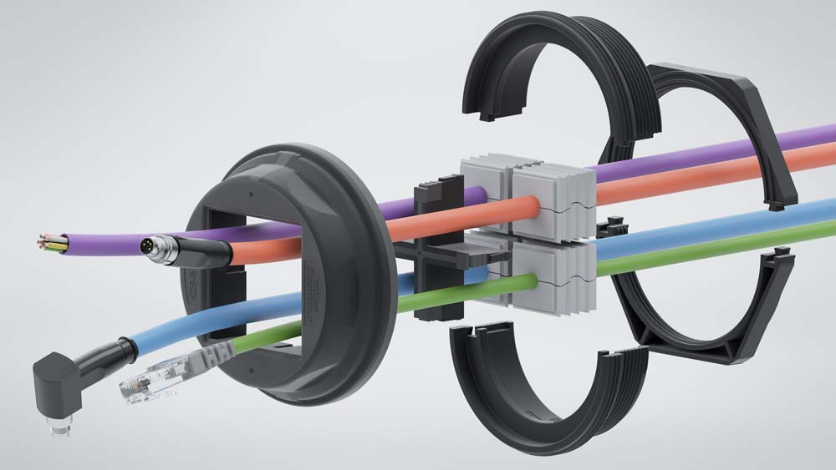
Illustration: The tool-less system offers versatile options for IP66 cable entry

Illustrations: | kds-r_m63 | Char.s: | 1578
File name: | 201904030_pm_kds-r_round_cable_entries_en | Date: | 07-31-2019
About CONTA-CLIP
CONTA-CLIP is one of Europe’s leading manufacturers of electrical and electronic connection elements and cable management solutions. Based in Hövelhof, Germany, the medium-sized, family-run company has been producing electric and electronic connection systems for the process and automation industries for 40 years. CONTA-CLIP supplies all industry sectors, focusing on railroad industries, shipbuilding, building automation, conveyor technology, machine and plant engineering and construction, instrumentation and control technology, control panel manufacturing, transformer manufacturing, and environmental technology. The company consists of three specialized branches: CONTA-CONNECT for electric connection technology, CONTA-ELECTRONICS for electronics and CONTA-CON for PCB edge connectors. Additionally, CONTA-CLIP provides services such as customizing housings and mounting rails, labeling and supplying user-specific electronic components.

Contact:  CONTA-CLIP  Verbindungstechnik GmbH  Christian Quade  Otto-Hahn-Str. 7  33161 Hövelhof  Germany  Phone: +49 . 5257 . 9833 - 0  Fax: +49 . 5257 . 9833 - 33  Email: christian.quade@conta-clip.de  Internet: www.conta-clip.com | gii die Presse-Agentur GmbH  Immanuelkirchstr. 12  10405 Berlin  Germany  Phone: +49 . 30 . 538 965 - 0  Fax: +49 . 30 . 538 965 - 29  Email: info@gii.de  Internet: www.gii.de

