Press Release

RAFI illuminated pushbutton in stainless steel design with ring lighting

RAFI has expanded its RAFIX 30 FS⁺ control component program with illuminated pushbuttons in a modern, stainless steel design. The new models come with ring lighting, a stylish front ring, and a button surface with a metal V2A insert. The extremely flat structure means the button stands just 3.45 mm proud of the front panel for an elegant appearance. The pushbuttons are available with white, red, green, yellow, or blue lighting rings. The illumination is provided by an LED. The pushbuttons feature IP65 degree of protection to the front side and, like all RAFIX 30 FS⁺ control and signaling units, they fit standard 30.3 mm installation openings. Even through gloves, the tactile feedback is clear. For terminal connection, the pushbuttons can be combined with PCB switching elements for PCB application or QC switching elements for conventional wiring. The PCB version has a mounting depth of just 15.7 mm, and the switching elements with LEDs and other components are located on a common board. The QC switching elements are connected individually with 2.8 mm x 0.8 mm quick connectors, resulting in a mounting depth of 33.3 mm. Illumination is via a plug-in LED clip. Both types of switching elements are available in versions with gold contacts for a maximum 35 V and 100 mA or with silver contacts for up to 250 V and 4 A.

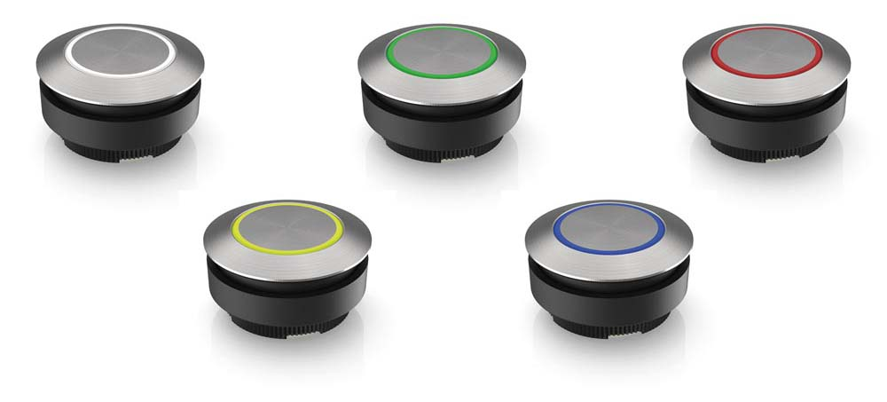
Caption: RAFIX 30 FS+ pushbutton with ring lighting

Image/s: | RAFIX_30_FS_Ringausleuchtung | Characters: | 1332
File name: | 202005027_PM_RAFIX_30_FS_mit_V2A-Edelstahleinlage_und_Ringausleuchtung_en | Date: | 09-01-2020
About the RAFI group
Founded in 1900, RAFI today develops and produces electromechanical components and systems for human–machine interaction. The range of products includes pushbuttons, switches, touchscreens, control systems and electronic assemblies. RAFI products are employed in many industries including automation, medical technology, machine and plant engineering, road and railway vehicles, household appliances and telecommunication. The RAFI group operates internationally with more than 2,000 employees at sites in Germany, Europe, China and the USA. Its headquarters are in Berg, Germany.

Contact:

RAFI GmbH & Co. KG
Artur Krug
Ravensburger Str. 128-134
88276 Berg
Germany
Phone: +49 . 751 . 891 307
Email: artur.krug@rafi.de
Internet: www.rafi.de

