Press Release

High-voltage compressor motor for steelworks

Linde India Ltd. was able to quickly source a new 11-MW high-voltage motor for a compressor in a steel plant from German manufacturer Menzel Elektromotoren. After the originally installed third-party motor had failed, downtime in the plant in the eastern state of Odisha could thus be kept short. Menzel has an extensive inventory, which is adapted to the demand. The motor manufacturer picked a modular squirrel-cage motor from its MEBKSW series for this project. These motors are by default very well adapted to the ambient conditions with temperatures up to 50 °C and a humidity of up to 95 %. Their tropics-proof motor winding conforms with temperature class F. Menzel fitted the motor with an air-to-water heat exchanger (cooling type IC 81W), which is ideal for environments with high humidity and highly polluted atmosphere, and implemented an increased IP55 ingress protection.

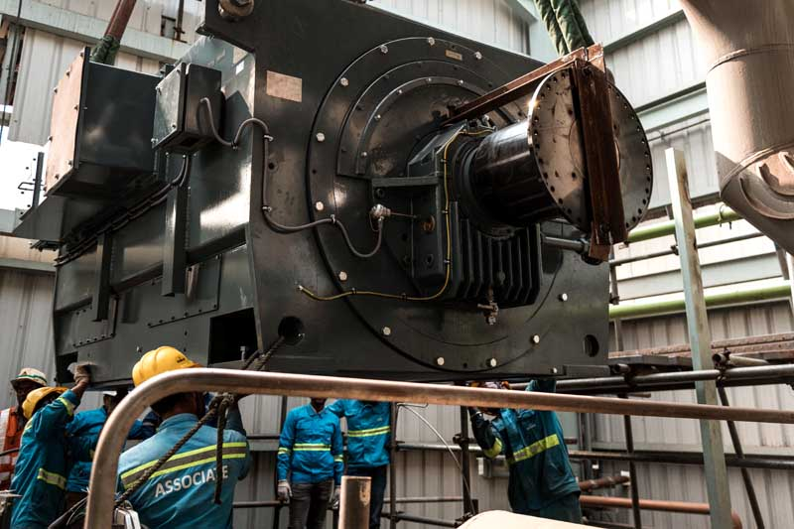
Caption: Menzel quickly adapted the motor from its modular range, ensuring smooth installation and commissioning

Menzel also made several mechanical and electrical adjustments to ensure smooth installation on site. One noteworthy challenge was that the original terminal box, complete with the sensors installed inside, should be moved to the new motor. To accomplish this Menzel not only manufactured a mounting adapter, but also changed the winding ends and routed them from the overhang to the terminal box along the side of the motor housing. Menzel furthermore built a base frame to adapt the motor size and mounting dimensions to the existing foundation. The motor with a rated voltage of 11 kV is designed for 50-Hz operation with a rated speed of 1492 min⁻¹ in continuous operation (operating mode S1). Its total weight is 23.5 tons. Before shipping, the motor underwent extensive tests in Menzel's load test field with the customer present. The manufacturer was also in charge of commissioning.
More information about water-cooled squirrel-cage motors for extreme ambient conditions is available at https://www.menzel-motors.com/squirrel-cage-motor/ic81w-ic86w/.

Image/s: | compressor_motor_steelworks_india | Characters: | 1942
File name: | 202003022_pm_compressor_motor_steel_en | Date: | 04-29-2020
About Menzel Elektromotoren
Based in Berlin, Menzel Elektromotoren GmbH has been manufacturing and distributing electric motors for more than 90 years. The medium-sized company specializes in the delivery of large electric motors, including special models, within the shortest possible time. The product range comprises high and low voltage motors, DC motors, transformers, and frequency inverters. Services include motor production and short-term adaptation of stocked motors to application-specific requirements. In order to ensure fast deliveries to the customer at all times, the company maintains a very extensive inventory including more than 20,000 motors with a maximum performance of up to 15,000 kW. Qualified engineering, experienced staff, and state-of-the-art production and testing facilities help Menzel provide excellent reliability. Menzel operates subsidiaries in the UK, France, Italy, Spain, and Sweden, and cooperates with numerous partners worldwide.

Contact:  Menzel Elektromotoren GmbH  Mathis Menzel  Neues Ufer 19-25  10553 Berlin  Germany  Phone: +49 . 30 . 349 922-0  Email: info@menzel-motors.com  Internet: www.menzel-motors.com | gii die Presse-Agentur GmbH  Immanuelkirchstr. 12  10405 Berlin  Germany  Phone: +49 . 30 . 538 965-0  Email: info@gii.de  Internet: www.gii.de

