Press Release

MIPI camera modules for embedded vision

Vision Components has launched a series of MIPI camera modules. The ultra-compact boards support the MIPI CSI-2 specification. They are available with different image sensors as required by the customer, starting off with six modules, two global shutter sensors – OV9281 from Omnivision (1 Megapixel) and Sony Pregius IMX296 (1.55 MP) – and four rolling shutter sensors, including IMX274 (8.4 MP) and IMX326 (6.8 MP) from the Sony Starvis series. Additional sensors with resolutions up to 13 MP are under development. Thanks to standardized data transmission, the miniature cameras can be manufactured and integrated into various platforms at extremely low costs. They are therefore ideal for applications with many cameras including mobile and distributed applications such as autonomous driving, UAVs, Smart City, medical technology, and laboratory automation. This development opens up a new product segment for the German manufacturer who has, until now, mainly specialized in cameras with built-in intelligence. Introducing the new MIPI sensor boards, VC now offers OEMs another highly versatile component for their embedded vision solutions.

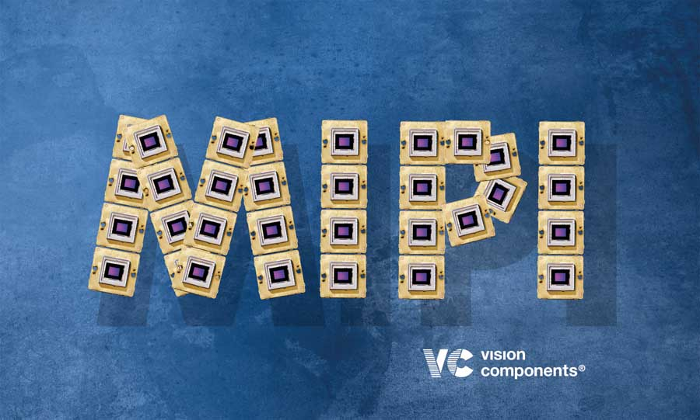
Illustration: The MIPI standard enables cost-effective integration of various image sensors

The MIPI camera modules contain mounting holes and precision fittings. A ceramic LGA chip ensures high mechanical stability and accuracy. It is placed on a copper layer with edge metallization for optimum heat dissipation and minimal noise. There is a connector for a 22-pin flexprint cable on the back of the high-end eight-layer board. The sensors can be triggered via this interface. The 200-mm flexprint cable included in delivery features a fully shielded backside and differential line pairs, ensuring noise-free MIPI transmission. At launch, the camera modules can be connected to more than 20 CPU boards from different manufacturers that support this standard. This includes all Raspberry Pi boards, all 96Boards, NVIDIA TX1 and TX2, and additional boards with i.MX6 / i.MX8.

Illustrations: | vc_mipi | Char.s: | 1930
File name: | 201901025_pm_mipi_camera_modules_en | Date: | 02-04-2019
About Vision Components
Founded in 1996 by Michael Engel, inventor of the first intelligent camera for industrial applications, Vision Components GmbH is a leading supplier in the field of machine vision. Branches and distributors represent the Ettlingen-based company throughout the world in more than 25 countries. Vision Components develops and distributes intelligent, network-compatible real-time Smart Cameras that are able to operate without a PC. These embedded vision solutions can be easily integrated into almost any machine or plant. Customers can choose between models with ARM processors and VC Linux firmware, or DSP-based models with the proprietary VCRT operating system. The product portfolio includes Smart Cameras with or without a protective housing, single board cameras, and vision sensors. Vision Components also develops custom-tailored machine vision solutions for a wide range of applications – including, amongst others, tasks in quality inspection and automation. Furthermore, VC provides software libraries for many applications such as motion capture, decoding, measurement, and positioning.

Contact:  Vision Components GmbH  Miriam Schreiber  Ottostr. 2  76275 Ettlingen  Germany |  | gii die Presse-Agentur GmbH  Immanuelkirchstr. 12  10405 Berlin  Germany  Tel.: +49 30 / 5389 650  Email: info@gii.de  WWW: www.gii.de
Tel.: +49 7243 / 216 716
Email: miriam.schreiber@vision-components.com
WWW: www.vision-components.com

