Press Release

Dragon High Power:
New fan air nozzle for camera enclosures

Camera applications in dirty industrial environments require appropriate devices to keep the windows of protective enclosures free from dust, moisture and oily substances. Pneumatic devices from autoVimation such as wind curtains, protective flaps and air nozzles have proven themselves to be efficient protection methods against window contamination that impairs vision. Introducing the Dragon High Power fan nozzle, the German manufacturer now provides a new solution for its Salamander, Gecko and Orca series protective enclosures, which combines economical compressed air consumption and low noise emissions with high blowing force. The tiltable air nozzle blows a fan-shaped air jet over the enclosure window at a 20° angle. Due to its blowing force of 3.3 N at a pressure of 5 bar and an air flow of 333 liters per minute, Dragon High Power prevents dirt accumulation and can remove even severe pollution. The blowing force of the nozzle corresponds to an open pipe with an inner diameter of 4 mm, but the energy consumption is 33 % lower and noise is reduced by 40 % to 82 dB(A). The air fan is wide enough to clean 3-inch windows at only 50 mm from the nozzle outlet. Therefore, Dragon High Power can be directly affixed to the protective camera enclosure, saving installation space. autoVimation also supplies brackets with dovetail connection as accessories for flexible mounting and orientation of the nozzle on the enclosure.

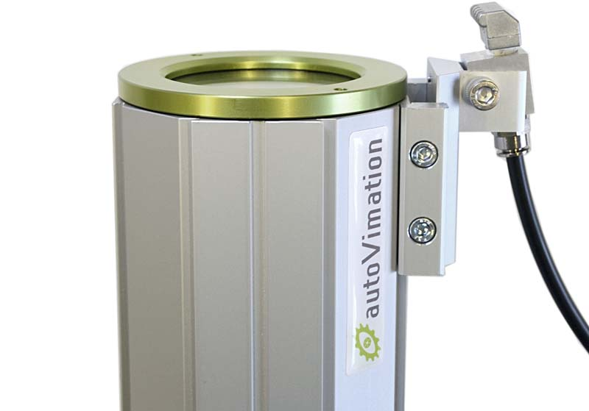
Caption: The new Dragon High Power fan air nozzle from autoVimation keeps camera enclosure windows clean

Image/s: | dragon |  | Characters: | 1437
File name: | 202209026_pm_dragon_high_power_fan_nozzle_en |  | Date: | 11-16-2022
About autoVimation
The German manufacturer autoVimation was founded in 2008 by Peter Neuhaus to provide solutions for easier installation and adjustment of image processing components. The company has developed a modular construction kit that simplifies the connection of all required components, which does away with costly and time-consuming manufacturing of dedicated mounting brackets. The product portfolio also includes compact, easy-to-integrate enclosures that provide optimal protection for cameras and lenses in industrial applications, and ensure good heat dissipation. autoVimation supplies complete, ready-to-install mechanical solutions for cameras and light fittings, and enables the integration of special lenses, filters, light barriers, encoders, or other sensors.
autoVimation's customers include renowned companies from various industry branches, such as the pharmaceutical and food industry, measuring technology, quality control, and security technology.
Contact:  autoVimation GmbH  Peter Neuhaus  Roemerweg 1  76287 Rheinstetten  Germany  Phone: +49 . 721 . 627 6756  Email: sales@autovimation.com  Internet: www.autovimation.com |  | gii die Presse-Agentur GmbH  Immanuelkirchstr. 12  10405 Berlin  Germany  Phone: +49 . 30 . 538 9650  Email: info@gii.de  Internet: www.gii.de

