Press Release

Automatic brake module for intra-logistics

Losyco expands its LOXrail intra-logistics system for the mechanical engineering industry, introducing an innovative brake module that fully automatically stops loads transported on rails. Specified for manually operated trolleys and transport platforms, the SmartBrake system autonomously safely stops trolleys and loads if the track is blocked by an obstacle or when the operator stops pushing. This is enabled by special sensors with pattern detection active in two directions. Both detection methods reliably activate the brake even with protruding loads. They automatically switch functions when the direction of travel is reversed. Sensors at the rear detect the step pattern and activate the brake as soon as the operator stops pushing. Upon restarting, the brake is automatically released. Sensory obstacle detection towards the front automatically stops the platform if persons or objects block the path. The manufacturer configures the newly engineered SmartBrake module for individual customer projects. The self-reinforcing system is not subject to load limitation and can be adapted for all manually operated transport trolleys for LOXrail floor rails with a 25 or 40-mm diameter.

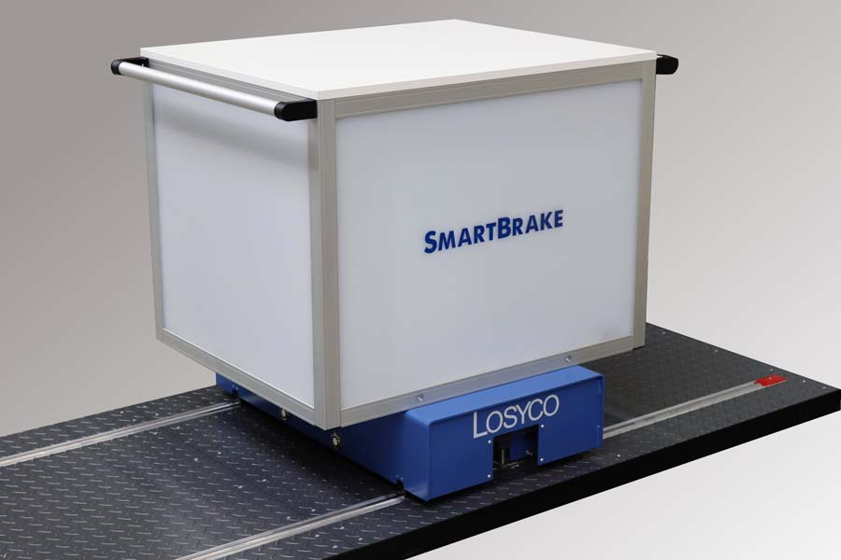
Caption: Losyco expands its LOXrail intra-logistics systems, launching a fully automatic brake module for manually operated trolleys

Image/s: | bremsmodul_2000 | Characters: | 1193
File name: | 202010020_pm_smartbrake_en | Date: | 10-21-2020
About Losyco
Based in Bielefeld, Germany, Losyco designs, manufactures, and deploys intra-logistics systems for industrial customers. Founded by experienced engineers in 2016, the company's first core product is LOXrail®: with this novel round bar rail system, loads weighing several tons can be easily moved around, precisely to the desired spot. It can be operated manually or with auxiliary drives. Losyco also supplies conveying and handling equipment such as chain and roller conveyors, material management and storage systems, sound-proof cabins, and machine covers. In addition, Losyco offers support and guidance for customers wishing to transform their production processes to implement lean manufacturing and continuous flow production. Losyco is a member of the DRECKSHAGE Family.

Contact:  LOSYCO GmbH  Member of the DRECKSHAGE Family  Manuel Granz  Walter-Werning-Str. 7  33699 Bielefeld  Germany  Tel.: +49 . 521 . 945 643-0  Fax: +49 . 521 . 945 643-399  Email: info@losyco.com  Internet: www.losyco.com | gii die Presse-Agentur GmbH  Immanuelkirchstr. 12  10405 Berlin  Germany  Tel.: +49 . 30 . 538 965-0  Fax: +49 . 30 . 538 965-29  Email: info@gii.de  Internet: www.gii.de

