Press Release

Customized heavy-duty joysticks

Adding to the already versatile JOYSCAPE platform, RAFI is now offering heavy-duty joysticks for outdoor machines and other applications in which control components must meet extremely demanding requirements. The platform concept enables a robust standard design base to be combined with customized multi-function joysticks. RAFI integrates buttons, rocker switches, thumb joysticks, rotary encoders, and LEDs as required. Employing wear-free noncontact electronic 3D Hall sensors for motion detection, the new heavy-duty joystick variant achieves a long operation lifetime even in the most demanding applications. It is built to sustain 5 million operating cycles even in extreme conditions and at environmental temperatures between -40 °C and +85 °C. The joystick has 110 Nm impact strength in X and Y direction. It handles pressure up to 1000 N and tensile loads up to 500 N in Z direction. The ferromagnetic, high-alloy steel housing effectively shields the sensor system for added ruggedness. The sensors are designed redundantly for superior reliability and safety. Due to its high center of rotation and large 20° tilt angle, the joystick only needs a small, 65 mm wide mounting hole. This particular design provides for very comfortable operation. In addition, it is suitable for bellows with a minimum of folds, which makes this an easy-to-clean solution. The joystick is very compact, featuring a mounting depth of only 50 mm and 77 x 77 mm flange dimensions.

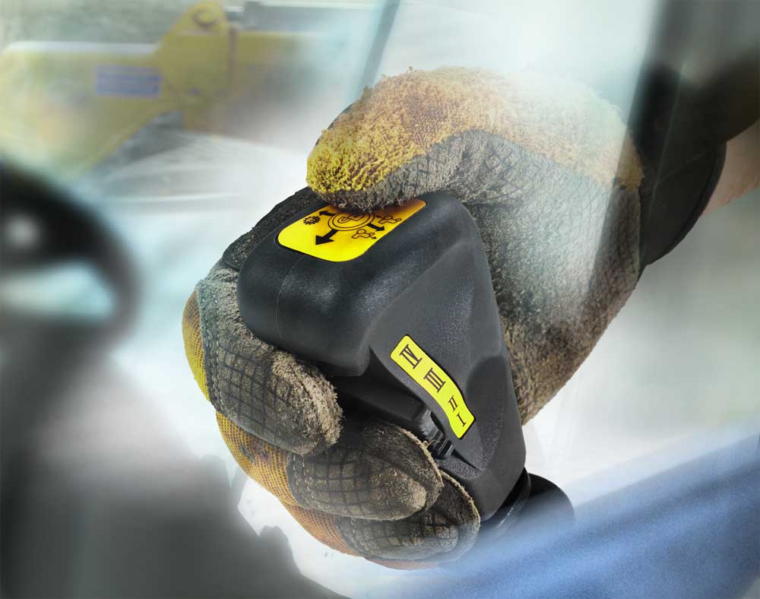
Illustration: RAFI engineers and builds custom joysticks for commercial vehicles and industrial applications based on the JOYSCAPE platform

Illustrations: | joyscape_heavy-duty_handschuh | Char.s: | 1469
File name: | 201809009_pm_joyscape_heavy-duty_joysticks_en | Date: | 11-21-2018
Company background RAFI group
Founded in 1900, RAFI now develops and produces electromechanical components such as pushbuttons and switches, operating systems such as touch screens, keyboards, electronic components, and systems for man-machine communication. RAFI products are employed in more than 30 industries, e.g., in medical equipment, mechanical engineering, road and railway vehicles, household appliances, and telecommunications. The RAFI group operates internationally with approx. 2,500 employees at ten sites in Germany, Europe, China, and the USA. The group’s headquarters are located in Berg (Baden-Württemberg, Germany).

Contact:  RAFI GmbH & Co. KG  Artur Krug  Ravensburger Str. 128-134  88276 Berg  Germany  Tel.: +49 . 751 . 891 307  Fax: +49 . 751 . 891 300  e-mail: artur.krug@rafi.de  WWW: www.rafi.de |  | gii die Presse-Agentur GmbH  Immanuelkirchstr. 12  10405 Berlin  Germany  Tel.: +49 . 30 . 5389 650  Fax: +49 . 30 . 5389 6529  email: info@gii.de  Internet: www.gii.de

