Press Release

Round cable entries for diameter combinations up to 22.5 mm

CONTA-CLIP further expands its KES-E cable entry program for screwless mounting, adding metric 50 mm variants: the new KES-E-R cable entries allow for quick and secure feeding of cables into control cabinets or machine housings. The plates are simply manually pressed into the machined openings. The inner, elastic sealing lip of the profile seal bulges on the inside of the panel, ensuring secure and vibration-proof hold. In order to feed cables or hoses into a housing, users simply pierce the surface membrane at one of the marked center points and push the conduit through. The new KES-E-R cable entries are available in seven A and seven B versions for cables and pneumatic hoses with diameters from 1 mm to 22.5 mm. The A versions are suitable for wall thicknesses from 1.5 mm to 2.5 mm, the B versions for 2.5 mm to 4 mm. Different versions hold up to 35 cables or conduits, thus allowing for extraordinarily high packing densities. The cable entries provide IP54 protection against dust and splash water. They are made of TPE and are free of halogen and silicone. The material is suitable for ambient temperatures from -40 °C to 90 °C.

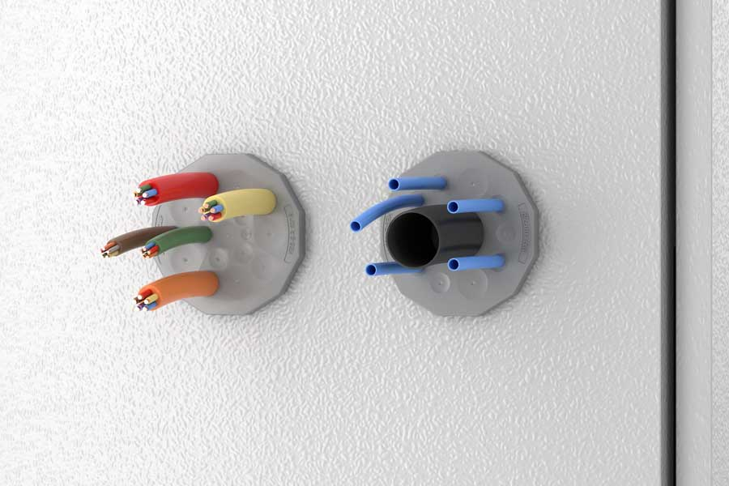
Caption: The tight-fitting, easy-to-mount cable entries hold up to 35 cables or conduits of different diameters

Image/s: | kes-e-r_fitted | Characters: | 1144
File name: | 202106022_pm_kes-e-r_round_cable_entries_en | Date: | 07-22-2021
About CONTA-CLIP
CONTA-CLIP is one of Europe’s leading manufacturers of electrical and electronic connection elements and cable management solutions. Based in Hövelhof, Germany, the medium-sized, family-run company has been producing electric and electronic connection systems for the process and automation industries for 40 years. CONTA-CLIP supplies all industry sectors, focusing on railroad industries, shipbuilding, building automation, conveyor technology, machine and plant engineering and construction, instrumentation and control technology, control panel manufacturing, transformer manufacturing, and environmental technology. The company consists of many specialized branches: CONTA-CONNECT for electric connection technology, CONTA-CABLE for cable management systems, CONTA-ELECTRONICS for electronics and CONTA-CON for PCB edge connectors. Additionally, CONTA-CLIP provides services such as customizing housings and mounting rails, labeling and supplying user-specific electronic components.

Contact:  CONTA-CLIP  Verbindungstechnik GmbH  Christian Quade  Otto-Hahn-Str. 7  33161 Hövelhof  Germany  Phone: +49 . 5257 . 9833 - 0  Fax: +49 . 5257 . 9833 - 33  Email: christian.quade@conta-clip.de  Internet: www.conta-clip.com | gii die Presse-Agentur GmbH  Immanuelkirchstr. 12  10405 Berlin  Germany  Phone: +49 . 30 . 538 965 - 0  Fax: +49 . 30 . 538 965 - 29  Email: info@gii.de  Internet: www.gii.de

