Press Release

Deep-learning-driven ALPR/ANPR software suite

The Carrida software engine for automatic license plate recognition (ALPR/ANPR) has been augmented by a make and model identification function featuring deep learning algorithms. Carrida Make & Model currently recognizes hundreds of European and US brands and models. It can be used as a standalone tool or in combination with license plate recognition to increase accuracy. Since it was first introduced in 2014, many OEMs have found Vision Components’ powerful, field-proven solution to be instrumental for access control, traffic monitoring, and smart city applications. A recently established dedicated subsidiary, Carrida Technologies GmbH, has now taken the lead in marketing and further developing the suite.

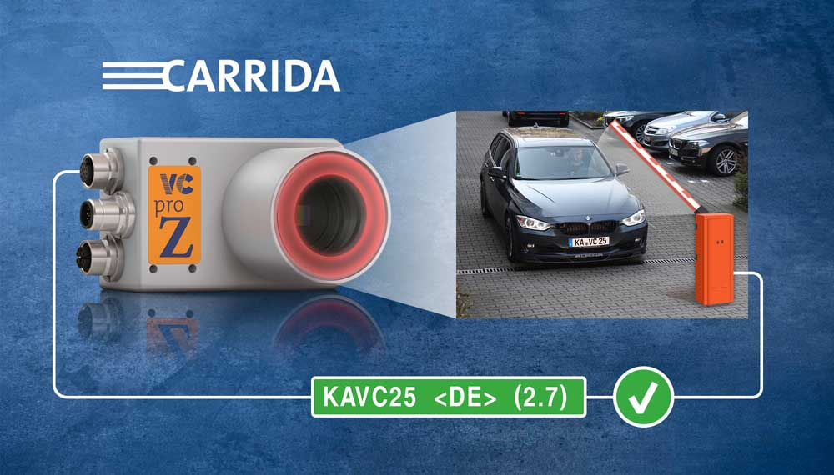
Illustration: Carrida provides a hardware-independent ALPR software with global functionality and a cost-optimized, weather-proof standalone camera

The core element is the Carrida software, which now reads license plates from over 50 countries around the world with a typical accuracy of 96 %. The software can process all widely used image and video file formats. It recognizes all license plates visible in an image, requiring a minimum character size of merely 8 pixels. Video stream processing can be tied to a motion detection trigger to save computing capacity. The hardware-independent software runs on Windows, Linux, and Android systems with a variety of different processors from Ambarella, Atom, and Broadcom, to HiSilicon, i5, i7, RasPi, and Zynq. This greatly facilitates Carrida integration, especially into heterogeneous hardware architectures. An intuitive web interface enables flexible, convenient operation. A REST API interface has now also been implemented. It has already been used for cloud applications. The release for Android devices gives users completely new opportunities in apps. Developer interfaces are available for C, C++, C# wrapper, Java wrapper, and Python. In addition to the software suite, Vision Components and Carrida Technologies also offer an ALPR hardware companion kit. The portfolio includes network-enabled cameras, which can optionally be operated as standalone systems to control access barriers, infrared lighting, and upgrade computing modules to turn conventional IP cameras into ALPR systems.

Illustrations: | carrida_access_control | Char.s: | 2113
File name: | 201904022_pm_carrida_deep_learning_alpr_en | Date: | 05-16-2019
About Vision Components
Vision Components is a leading international manufacturer of embedded vision systems. The freely programmable cameras with powerful onboard CPUs perform image processing tasks on their own without the need for an additional computer. Vision Components offers OEMs versatile Linux-based embedded systems for 2D and 3D image processing, supplied as board cameras or in protective casings. These are complemented by a growing range of ultracompact MIPI camera boards, which connect to a variety of different CPU boards. In addition, Vision Components offers software libraries and develops customized solutions on request. The team of experts can draw on extensive knowledge and over 20 years of experience with imaging applications. The company based in Ettlingen in southwestern Germany was founded in 1996 by Michael Engel, the inventor of the first industrial-grade intelligent camera. More world premieres followed, including the world's first intelligent vision sensors and the first-ever embedded 3D laser profiler. Today, Vision Components has sales offices in the United States and Japan and works with local partners in over 25 countries to provide consistent customer focus and readily available expertise throughout the world.

Contact:  Vision Components GmbH  Miriam Schreiber  Ottostr. 2  76275 Ettlingen  Germany  Phone: +49 . 7243 . 216 716  Email: miriam.schreiber@vision-components.com  Internet: www.vision-components.com  www.carrida-technologies.com | gii die Presse-Agentur GmbH  Immanuelkirchstr. 12  10405 Berlin  Germany  Phone: +49 . 30 . 538 9650  Email: info@gii.de  Internet: www.gii.de

