Press Release

Tool-less round cable entries for cables with plugs

Conta-Clip completes its KDS-R modular cable entry program for round metric breakouts from M20 to M63, adding small-diameter versions for cables and conduits with cross-sections from 2 mm to 35 mm. Cables with and without plugs can thus be quickly and safely fed into control cabinets or housings. The tool-less cable management system consists of a handful of modular components: a cable entry frame with an integrated gasket, a two-piece thread and locking adapter plus two-piece locknut to fix it in place, and sealing elements with a range of inlays. The cables are simply fed through the enclosure opening and cable entry frame. Slit, tapered, and finned sealing elements are then fitted around individual cables or conduits on the inside. The sealing elements are then pushed back to fit tight in the cable entry frame. I-, T-, and +-shaped inlays are available for M40 and larger openings, allowing for insertion of a variety of cable sealing elements as required. The cable entry frame as a whole is fixed in place by attaching a two-part thread and locking adapter to the frame on the outside of the enclosure and attaching a separable locknut on the inside. The special shape of the sealing elements ensures high IP66 ingress protection and strain relief working towards accordance with the DIN EN 62444 standard. The wide range of sealing elements for one or more cables of different shapes and diameters offers high flexibility in creating wiring solutions. The tool-less system minimizes the effort necessary to change existing connections. Unused entry positions in the frame can be sealed with blanking plugs, which can be easily removed at any time to allow additional cables to be inserted.

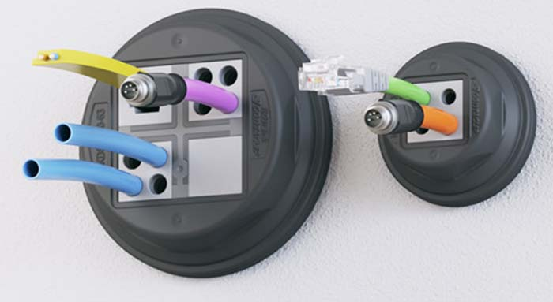
Caption: The tool-less round cable entry system accommodates all kinds of cables and conduits, ensuring IP66 ingress protection

Image/s: | KDS-R | Characters: | 1707
File name: | 202107019_pm_kds-r_round_cable_entries_en | Date: | 09-16-2021
About CONTA-CLIP
CONTA-CLIP is one of Europe’s leading manufacturers of electrical and electronic connection elements and cable management solutions. Based in Hövelhof, Germany, the medium-sized, family-run company has been producing electric and electronic connection systems for the process and automation industries for 40 years. CONTA-CLIP supplies all industry sectors, focusing on railroad industries, shipbuilding, building automation, conveyor technology, machine and plant engineering and construction, instrumentation and control technology, control panel manufacturing, transformer manufacturing, and environmental technology. The company consists of many specialized branches: CONTA-CONNECT for electric connection technology, CONTA-CABLE for cable management systems, CONTA-ELECTRONICS for electronics and CONTA-CON for PCB edge connectors. Additionally, CONTA-CLIP provides services such as customizing housings and mounting rails, labeling and supplying user-specific electronic components.

Contact:  CONTA-CLIP  Verbindungstechnik GmbH  Christian Quade  Otto-Hahn-Str. 7  33161 Hövelhof  Germany  Phone: +49 . 5257 . 9833 - 0  Fax: +49 . 5257 . 9833 - 33  Email: christian.quade@conta-clip.de  Internet: www.conta-clip.com | gii die Presse-Agentur GmbH  Immanuelkirchstr. 12  10405 Berlin  Germany  Phone: +49 . 30 . 538 965 - 0  Fax: +49 . 30 . 538 965 - 29  Email: info@gii.de  Internet: www.gii.de

