Press release

New ring force sensors from Inelta

Inelta is expanding its range of custom-made sensors to include ring force sensors for measuring the axial forces applied to screws, shafts, or axles. Typical applications for this type of sensor – which are also known as “load washers” because of how they are fitted – include determining or monitoring the pre-tensioning forces of screw connections.
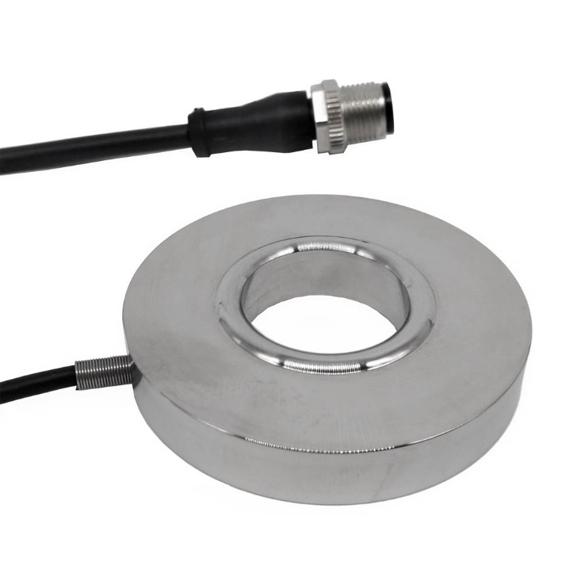
Caption: Inelta is expanding its product range to include customized ring force sensors.

The compact models in the new series have an external diameter of up to 60 mm and can record compressive forces of up to 200 kN. Depending on the desired through-hole size, the installation height is just 8 to 11 mm. Another of the company’s innovations in this area are the versions with an integrated signal conditioner. Thanks to the full-bridge strain gauge configuration, the stainless steel deformation elements, and flat contact surface measuring just 0.05 mm, the new ring force sensors ensure a very high level of insensitivity to eccentric forces. Inelta supplies the standard models in an encapsulated design together with a matching signal conditioner – and can also be provided with an integrated newton indicator if required. Further versions of the ring force sensor are currently under development at Inelta.

Application know-how is key
The reliability of a measurement solution not only depends on the use of robust sensor technology, but also on specific design features of the selected sensor models, their application-specific configuration, and correct placement. That is why Inelta, as a specialist in industrial sensor technology, supports its customers with comprehensive application know-how, in-depth advice and, where required, also carries out custom-fit modifications to its products.

Image/s: | Ringkraftsensor | Characters: | 1,753
File name: | 202202009_pm_ringkraftsensoren_en | Date: | 02-16-2022

Company background
Inelta Sensorsysteme GmbH & Co. KG, based in Taufkirchen near Munich, has been developing, producing, and selling standard and customized sensor solutions for industrial applications since 2000. Together with PIL Sensoren GmbH (Erlensee near Frankfurt/Main), a pioneer in the field of ultrasonic technology, and VYPRO s.r.o. (Trenčín, Slovakia), the company offers a wide range of products for measuring the displacement and position of an object, as well as force, pressure, and inclination. The range of products we offer includes force sensors, sensor signal amplifiers, pressure switches, capacitive sensors, and ultrasonic sensors. Cable and connector assembly services round off our portfolio.
Our group of companies supplies products and services to customers in the industrial automation, mechanical engineering, hydraulics, medical technology, and aerospace industries. We focus particularly on industry and customer-specific sensor solutions, which are constantly being enhanced thanks to our interdisciplinary expertise.

Contact:  Inelta Sensorsysteme GmbH & Co. KG  Reinhard Koch  Ludwig-Bölkow-Allee 22  82024 Taufkirchen  Phone: +49 (0) 89 / 45 22 45-0  Fax: +49 (0) 89 / 45 22 45-744  E-mail: reinhard.koch@inelta.de  Internet: www.inelta.de |  | gii die Presse-Agentur GmbH  Immanuelkirchstraße 12  10405 Berlin  Phone: +49 (0) 30 / 53 89 65-0  Fax: +49 (0) 30 / 53 89 65-29  E-mail: info@gii.de  Internet: www.gii.de

