Press Release

Large low voltage motors for special applications

Menzel Elektromotoren has built eight low voltage motors with a shaft height of 500 mm for a rolling mill. The company, which specializes in tailor-made solutions, played to its strengths in this project by building the mill drives from scratch, according to the plant manufacturer's requirements, while meeting a very tight 16 week timeline. The technologically demanding and high-end design ensures reliable operation under high mechanical stress. Robust welded steel housings ensure maximum torsional rigidity. At the customer's request, Menzel implemented a water cooling system (cooling type IC 86W). The motors feature a rated voltage of 690 V and provide 1000 kW rated power. Menzel designed them for the application-specific load points at a nominal frequency of 25 Hz and installed a special rotary encoder for inverter operation. The customer is completely satisfied and has already placed a follow-up order for four additional motors of the same type.
More information is available at: https://www.menzel-motors.com/squirrel-cage-motor/ic81w-ic86w/

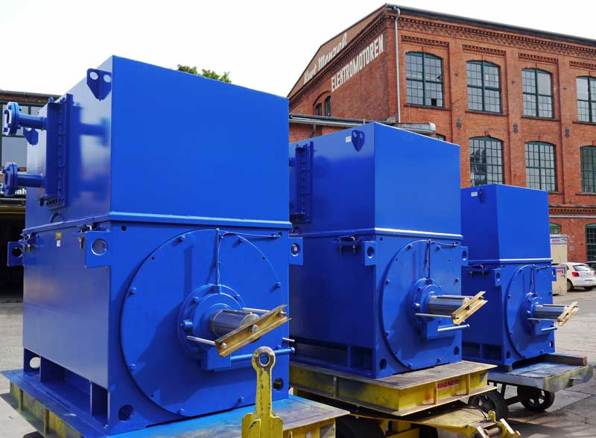
Caption: Menzel Elektromotoren manufactures LV motors to measure and in the shortest possible time, ensuring fail-safe operation of mills in steelworks

Image/s: | lv_motors_rolling_mill | Characters: | 962
File name: | 201909002_pm_low_voltage_motors_en | Date: | 09-04-2019
About Menzel Elektromotoren
Based in Berlin, Menzel Elektromotoren GmbH has been manufacturing and distributing electric motors for more than 90 years. The medium-sized company specializes in the delivery of large electric motors, including special models, within the shortest possible time. The product range comprises high and low voltage motors, DC motors, transformers, and frequency inverters. Services include motor production and short-term adaptation of stocked motors to application-specific requirements. In order to ensure fast deliveries to the customer at all times, the company maintains a very extensive inventory including more than 20,000 motors with a maximum performance of up to 15,000 kW. Qualified engineering, experienced staff, and state-of-the-art production and testing facilities help Menzel provide excellent reliability. Menzel operates subsidiaries in the UK, France, Italy, Spain, and Sweden, and cooperates with numerous partners worldwide.

Contact:  Menzel Elektromotoren GmbH  Mathis Menzel  Neues Ufer 19-25  10553 Berlin  Germany  Phone: +49 . 30 . 349 922-0  Email: info@menzel-motors.com  Internet: www.menzel-motors.com | gii die Presse-Agentur GmbH  Immanuelkirchstr. 12  10405 Berlin  Germany  Phone: +49 . 30 . 538 965-0  Email: info@gii.de  Internet: www.gii.de

