Press Release

RAFI stands out for innovation and reputation

RAFI is considered one of the most innovative companies in Germany and enjoys an excellent reputation with its customers, this according to the 2018 Deutschland TEST survey. This customer satisfaction survey covered the 5000 largest German companies in more than 140 industrial sectors. The study was commissioned by the German business magazine FOCUS MONEY. The market researchers awarded RAFI the 2018 Innovation Award for its novel products and substantial R&D investments in the development of electromechanical components, control systems, and industrial touchscreens. RAFI also won the Best Reputation seal of approval for management performance, superior product quality, excellent service, and environmental as well as economic sustainability. "We are very proud to accept these awards on behalf of our staff," said managing director Albert Wasmeier. "At RAFI, we strive to set standards through innovative developments for human-machine communication and seek to provide excellent service for our customers around the world. Therefore, this is a fine acknowledgment of our team effort."

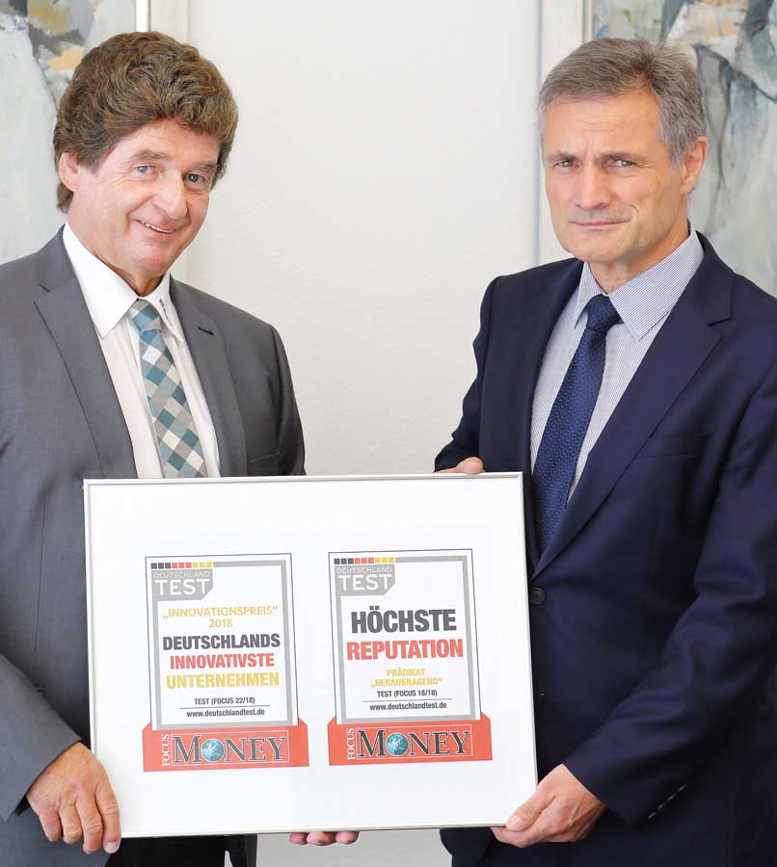
Illustration: Albert Wasmeier and Gerhard Schenk, managing directors of RAFI accept the FOCUS MONEY awards

RAFI has an extraordinary range of vertical manufacturing and offers a very diverse portfolio of products as well as development and manufacturing services. Building on the company's original production range of high-quality pushbuttons and switches, RAFI has diversified its portfolio and today manufactures electronic assemblies and full-scale control systems for various sectors including the automotive industry, machine building, agricultural vehicles, and medical technology. The electronics specialist is also one of the largest EMS providers in Germany and one of the few manufacturers in Europe with production facilities for large-sized industrial touchscreens. The company has won multiple awards for its vocational training program as well as for product design solutions. In the 2017 Deutschland TEST survey, it was recognized as one of Germany's top employers.

Illustrations: | Focus-RAFI-Auszeichnung | Char.s: | 1969
File name: | 201808038_pm_focus_money_awards_en | Date: | 09-12-2018
Company background RAFI group
Founded in 1900, RAFI now develops and produces electromechanical components such as pushbuttons and switches, operating systems such as touch screens, keyboards, electronic components, and systems for man-machine communication. RAFI products are employed in more than 30 industries, e.g., in medical equipment, mechanical engineering, road and railway vehicles, household appliances, and telecommunications. The RAFI group operates internationally with approx. 2,500 employees at ten sites in Germany, Europe, China, and the USA. The group’s headquarters are located in Berg (Baden-Württemberg, Germany).

Contact:  RAFI GmbH & Co. KG  Artur Krug  Ravensburger Str. 128-134  88276 Berg  Germany  Tel.: +49 . 751 . 891 307  Fax: +49 . 751 . 891 300  e-mail: artur.krug@rafi.de  WWW: www.rafi.de |  | gii die Presse-Agentur GmbH  Immanuelkirchstr. 12  10405 Berlin  Germany  Tel.: +49 . 30 . 5389 650  Fax: +49 . 30 . 5389 6529  email: info@gii.de  Internet: www.gii.de

