Press Release

A RAFI classic: The KN 19 tactile mains switch for under-membrane installation

Due to its extremely compact design and unique short operating stroke of just 0.55 mm, the KN 19 membrane-covered mains switch from RAFI can be integrated directly into low-profile data entry systems. Therefore, the tactile switches for AC rated voltages of 250 V and DC rated voltages of 12 V to 50 V can replace conventional mains switches without the need for cut-outs in the unbroken overlay. In the case of DC rated voltages, the rated current is 6 A. KN 19 switches are available in a single-pole version with a normally-closed contact plus a normally-open contact and in double-pole form with two normally-open contacts. As an alternative to installation under the overlay, the switch can also be fitted with keycaps from the RAFI RK 90 range. The standard overall height of 9.7 mm means the KN 19 can be combined with other RAFI tactile switches and electronic components on a single PCB. The manufacturer supplies the switches for grid spacing of 19.05 mm x 38.1 mm, also in illuminated types.

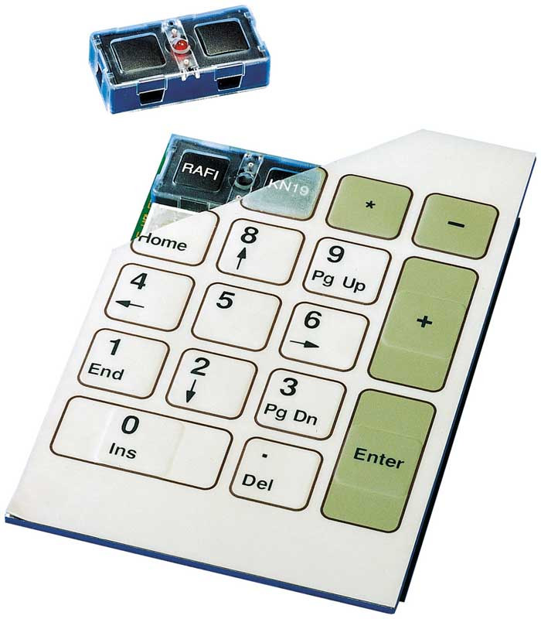
Caption: KN 19 tactile mains switch for 250 V AC with an operating stroke of just 0.55 mm

Image/s: | RAFI_KN19_in_Keyboard | Characters: | 1002
File name: | 202106007_pm_kn_19_tactile_mains_switch_en | Date: | 06-16-2021
About the RAFI group
Founded in 1900, RAFI today develops and produces electromechanical components and systems for human–machine interaction. The range of products includes pushbuttons, switches, touchscreens, control systems and electronic assemblies. RAFI products are employed in many industries including automation, medical technology, machine and plant engineering, road and railway vehicles, household appliances and telecommunication. The RAFI group operates internationally with 2,000 employees at sites in Germany, Europe, China and the USA. Its headquarters are in Berg, Germany.

Contact:

RAFI GmbH & Co. KG
Artur Krug
Ravensburger Str. 128-134
88276 Berg
Germany
Phone: +49 . 751 . 891 307
E-Mail: artur.krug@rafi-group.com
Internet: www.rafi-group.com

