Press Release

Express delivery of a 10-ton pump motor

After a pump motor failure at a gas-fired power plant in Chile, Menzel Elektromotoren manufactured a replacement in just three weeks. The 10-ton 6600 kV, 50 Hz squirrel-cage motor provides 2500 kW rated power. Menzel was able to quickly fulfill the urgent order due to the company’s unique policy of maintaining standard components for the most common industrial applications with outputs up to 18 MW always in stock with project-specific configuration performed in-house. In this case, this meant completely rebuilding the off-the-shelf motor. As a particular challenge, the motor had to perfectly fit the same mechanical interfaces with the existing base. Menzel therefore had to cut open the housing and adjust the footprint.

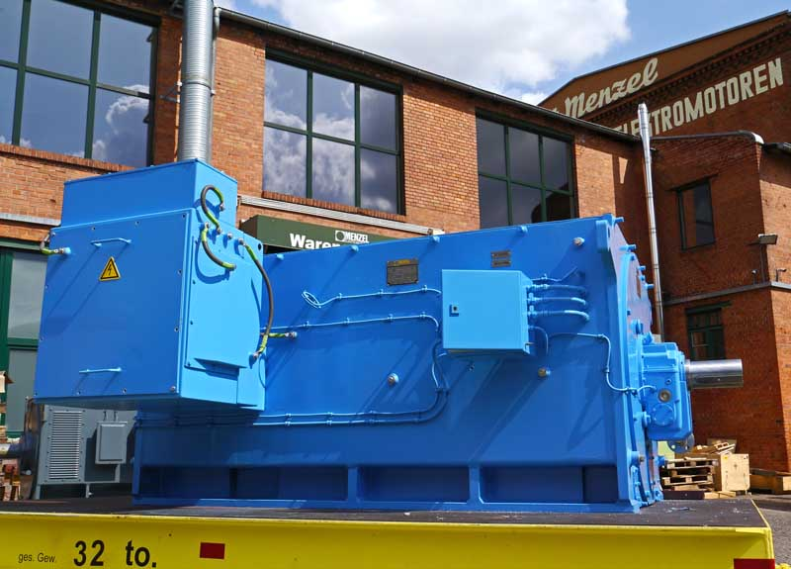
Caption: Menzel retrofitted a stock motor in just three weeks to replace a failed pump motor

Further necessary measures included changing the sleeve bearings from self-lubrication to forced oil lubrication and repositioning the terminal boxes. In addition, Menzel shortened and re-milled the shaft along with rebalancing the rotor. The customer project entailed comprehensive technical coordination to ensure smooth commissioning and operation. The customer, a major global pump manufacturer from Germany, had a personal contact in Menzel's technical office, ensuring optimal support. After in-house testing, Menzel dispatched the pump motor to Chile by air. At the same time, Menzel received a follow-up order: to ensure they do not encounter another unscheduled standstill, the end customer has ordered an identical reserve motor. This time, the motor manufacturer has a little bit more leisure to approach the job – with a delivery period of one month.
Menzel has manufactured pump motors for a wide range of applications in the past. More information is available at https://www.menzel-motors.com/pump-drive/.

Image/s: | pump_motor_power_plant | Characters: | 1747
File name: | 201909008_pm_pump_motor_power_plant_en | Date: | 09-25-2019
About Menzel Elektromotoren
Based in Berlin, Menzel Elektromotoren GmbH has been manufacturing and distributing electric motors for more than 90 years. The medium-sized company specializes in the delivery of large electric motors, including special models, within the shortest possible time. The product range comprises high and low voltage motors, DC motors, transformers, and frequency inverters. Services include motor production and short-term adaptation of stocked motors to application-specific requirements. In order to ensure fast deliveries to the customer at all times, the company maintains a very extensive inventory including more than 20,000 motors with a maximum performance of up to 15,000 kW. Qualified engineering, experienced staff, and state-of-the-art production and testing facilities help Menzel provide excellent reliability. Menzel operates subsidiaries in the UK, France, Italy, Spain, and Sweden, and cooperates with numerous partners worldwide.

Contact:  Menzel Elektromotoren GmbH  Mathis Menzel  Neues Ufer 19-25  10553 Berlin  Germany  Phone: +49 . 30 . 349 922-0  Email: info@menzel-motors.com  Internet: www.menzel-motors.com | gii die Presse-Agentur GmbH  Immanuelkirchstr. 12  10405 Berlin  Germany  Phone: +49 . 30 . 538 965-0  Email: info@gii.de  Internet: www.gii.de

