Press Release

CONTA-CLIP PRS plug-in relay system now also with push-in connection

CONTA-CLIP now also offers DIN-rail relay socket bases from its PRS plug-in relay system with push-in connection. The new PPRS sockets are available for relays with 1, 2 or 4 switching contacts. The push-in wire connection significantly reduces the time required for wiring. Inserted wires are loosened via integrated pushers, which can be operated without special tools. The relay socket bases are designed for a rated voltage of 300 V and can be flexibly configured with CONTA-CLIP's PRS relays for voltage ranges from 12 to 220 V DC or 12 to 230 V AC as well as the associated plug-in modules with LED status indicators. Each connection has a test tap for easy checking of the applied voltage. The comprehensive accessory range also includes the pluggable and touch-proof external cross-connection system AQI/PPRS for potential distribution to adjacent socket bases. Other feature options include snap-on brackets that fix the relays in place and also hold MC-MM-series markers.

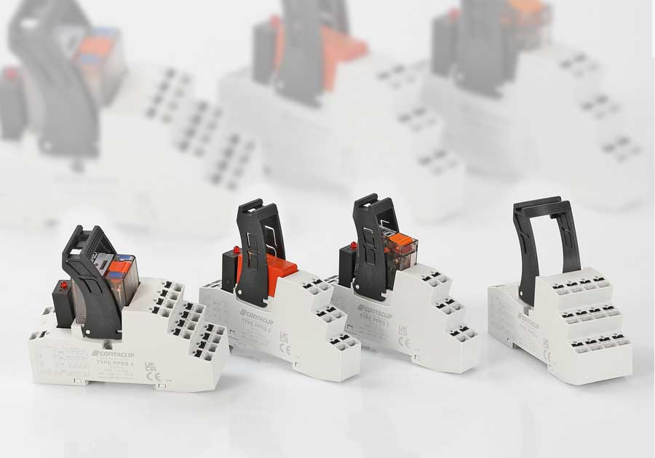
Caption: The new PPRS plug-in relay system with push-in wire connection reduces the wiring effort

Image/s: | PPRS_Reihe | Characters: | 981
File name: | 202205041_pm_pprs_push-in_relay_sockets_en | Date: | 06-29-2022
About CONTA-CLIP
CONTA-CLIP is one of Europe’s leading manufacturers of electrical and electronic connection elements and cable management solutions. Based in Hövelhof, Germany, the medium-sized, family-run company has been producing electric and electronic connection systems for the process and automation industries since 1978. CONTA-CLIP supplies all industry sectors, focusing on railroad industries, shipbuilding, building automation, conveyor technology, machine and plant engineering and construction, instrumentation and control technology, control panel manufacturing, transformer manufacturing, and environmental technology. The company consists of many specialized branches: CONTA-CONNECT for electric connection technology, CONTA-CABLE for cable management systems, CONTA-ELECTRONICS for electronics and CONTA-CON for PCB edge connectors. Additionally, CONTA-CLIP provides services such as customizing housings and mounting rails, labeling and supplying user-specific electronic components.
Contact:  CONTA-CLIP  Verbindungstechnik GmbH  Franziska Klein  Otto-Hahn-Str. 7  33161 Hövelhof  Germany  Phone: +49 . 5257 . 9833 - 173  Email: franziska.klein@conta-clip.de  Internet: www.conta-clip.com |  | gii die Presse-Agentur GmbH  Immanuelkirchstr. 12  10405 Berlin  Germany  Phone: +49 . 30 . 538 965 - 0  Email: info@gii.de  Internet: www.gii.de

