Press Release

FPGA-based accelerator for embedded vision with MIPI and new MIPI cameras with ToF, SWIR and Pregius sensors

Vision Components has developed an FPGA-based accelerator for edge preprocessing of image data in embedded vision projects with MIPI camera modules. The hardware accelerator with multiple MIPI-CSI-2 inputs and outputs enables complex image processing and image data analysis. The compact board can merge data from several MIPI cameras. It manages complex algorithms and computing operations thanks to a powerful, freely programmable FPGA. The accelerator will be available early in 2022, initially with a completely open FPGA for customer programming and demo applications. In a second phase, Vision Components will launch its own FPGA designs for specific applications such as color conversion, 1D barcode identification, epipolar correction, etc. In addition, there are plans to enable the electronics for AI acceleration. Vision developers can integrate the accelerator into their future electronics designs – just as easily and comfortably as a conventional MIPI camera module. The accelerator transfers image preprocessing results to a higher-level CPU via the MIPI channel. This allows users to perform even very complex tasks by means of in-depth preprocessing in the dedicated FPGA module, while they also benefit from the flexible selection of a highly efficient embedded system.

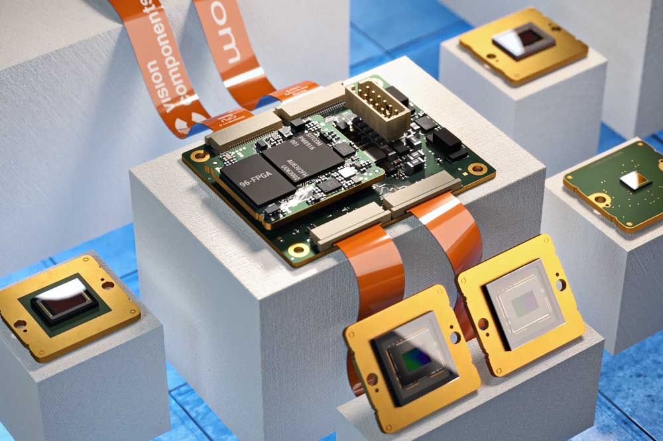
Caption: The compact, high-performance FPGA-based hardware accelerator enables complex image preprocessing in the MIPI data stream

Vision Components is also adding a variety of new MIPI camera modules to its existing range. The manufacturer has integrated the first time-of-flight sensor – the Melexis MLX75027 – into a 50 mm x 50 mm board with a MIPI-CSI-2 interface and lighting. The sensor's DepthSense technology with pixel sizes of only 10 μm x 10 μm enables high-resolution, high-contrast 3D imaging. The new ToF MIPI module will be available to order in 2021 yet, as will four additional MIPI camera boards with SONY Pregius S sensors – the newly integrated high-end sensors feature global shutters and resolutions up to 12 megapixels. Yet another addition to Vision Components' MIPI portfolio is upcoming: a line of MIPI camera modules for imaging in the short-wave infrared (SWIR) spectrum. Different sensor technologies will enable especially inexpensive SWIR applications.
Vision Components will present these, and more, new embedded vision solutions at its VISION tradeshow booth #8-C31.
Vision Components at the VISION trade fair
Stuttgart, Germany, 5 – 7 October 2021
Hall 8, Stand C31

Image/s: | vc_fpga_accelerator | Characters: | 2255
File name: | 202109033_pm_fpga_accelerator_en | Date: | 09-30-2021
About Vision Components
Vision Components is a leading international manufacturer of embedded vision systems. The freely programmable cameras with powerful onboard CPUs perform image processing tasks on their own without the need for an additional computer. Vision Components offers OEMs versatile Linux-based embedded systems for 2D and 3D image processing, supplied as board cameras or in protective casings. These are complemented by a growing range of ultracompact MIPI camera boards, which connect to a variety of different CPU boards. In addition, Vision Components offers software libraries and develops customized solutions on request. The team of experts can draw on extensive knowledge and over 20 years of experience with imaging applications. The company based in Ettlingen in southwestern Germany was founded in 1996 by Michael Engel, the inventor of the first industrial-grade intelligent camera. More world premieres followed, including the world's first intelligent vision sensors and the first-ever embedded 3D laser profiler. Today, Vision Components has sales offices in the United States and Japan and works with local partners in over 25 countries to provide consistent customer focus and readily available expertise throughout the world.
Contact:  Vision Components GmbH  Jan-Erik Schmitt  Ottostr. 2  76275 Ettlingen  Germany  Phone: +49 . 7243 . 21670  Email: schmitt@vision-components.com  Internet: www.vision-components.com |  | gii die Presse-Agentur GmbH  Immanuelkirchstr. 12  10405 Berlin  Germany  Phone: +49 . 30 . 538 9650  Email: info@gii.de  Internet: www.gii.de

