Press Release

RAFI at Agritechnica 2017: award-winning HMI solutions and implement tracking for commercial vehicles

Berg/Ravensburg, Germany – RAFI presents new HMI systems for smart farming at the Agritechnica exhibition in Hanover, Germany (hall 17, stand D41). Showcases include armrests for Valtra tractors and Kässbohrer PistenBully vehicles, the Bach onboard unit manufactured by RAFI for Openmatics, agricultural tracking systems for tools and attachments, as well as solutions for continuous machine and user behavior monitoring.

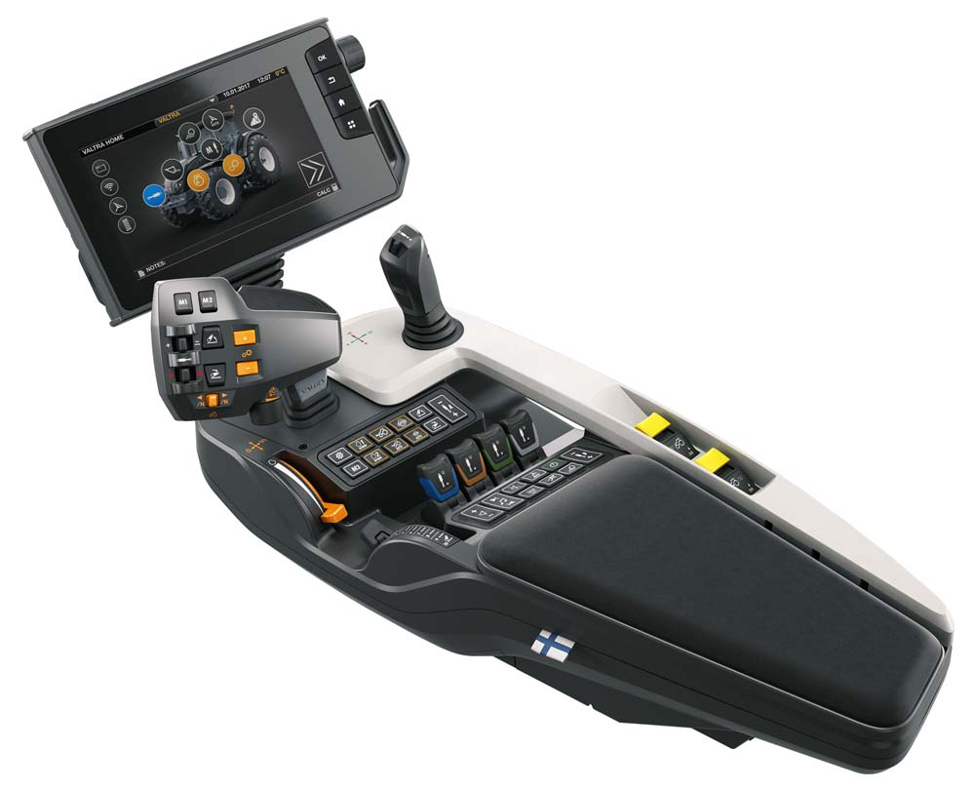
Illustration: One of RAFI's Agritechnica exhibits is the SmartTouch armrest for Valtra tractors

The new SmartTouch armrest developed by RAFI for the Valtra S series model S394 will also be integrated in N and T series rigs. This product won a 2017 Red Dot Design Award for its excellent ergonomics and well-thought-out arrangement of components. Visitors to the RAFI trade fair booth can try the farming simulator to get an up-close impression of this operating solution's high level of comfort. The booth also features a life-sized Valtra tractor cabin model equipped with the current design with the SmartTouch armrest. Furthermore, RAFI introduces its new control panel for the current PistenBully PB 100 series, which also integrates all control elements for vehicle and tool functions in the arm rest. The main joystick for controlling all vehicle and hydraulic functions features a sophisticated double joint functionality that allows for intuitive, flexible positioning of the plow. In addition, the handle integrates 18 switches, rocker switches, and rotary potentiometers for quick function selection, adjustment, and input acknowledgment. Kässbohrer will gradually implement consistent cockpits across the PistenBully series by equipping all models with this new high-performance solution.
Another notable presentation is an "Implement Tracking" application based on the Openmatics Bach box – a solution that demonstrates RAFI's advanced capabilities in the field of IoT in agriculture. In combination with "deTAGtiv" battery-powered sensor tags, the Bach onboard unit enables a networked system for localization and production data acquisition for agricultural implements such as balers, mowers, or seeders. The Implement Tracking tool makes such devices smart and enables efficient fleet management as well as significantly improved maintenance intervals.
RAFI's solution for user behavior monitoring is another trade fair highlight. Continuous condition monitoring of the armrest control unit enables an analysis of individual user behavior. The aggregate data can yield valuable insights into the system's real-life usability and ergonomics. On this basis, user behavior can be further optimized and the efficiency can be increased.

Visit RAFI at the 2017 Agritechnica exhibition in hall 17, at stand D41!
Hanover, Germany, 12 – 18 November 2017

Illustrations: | valtra_smarttouch | Char.s: | 2,542
File name: | 201711013_pm_agritechnica_en | Date: | 11-10-2017
Company background RAFI group
Founded in 1900, RAFI now develops and produces electromechanical components such as pushbuttons and switches, operating systems such as touch screens, keyboards, electronic components, and systems for man-machine communication. RAFI products are employed in more than 30 industries, e.g., in medical equipment, mechanical engineering, road and railway vehicles, household appliances, and telecommunications. The RAFI group operates internationally with approx. 2,100 employees at ten sites in Germany, Europe, China, and the USA. The group’s headquarters are located in Berg (Baden-Württemberg, Germany).

Contact:  RAFI GmbH & Co. KG  Artur Krug  Ravensburger Str. 128-134  88276 Berg  Germany  Tel.: +49 . 751 . 891 307  Fax: +49 . 751 . 891 300  e-mail: artur.krug@rafi.de  WWW: www.rafi.de |  | gii die Presse-Agentur GmbH  Immanuelkirchstr. 12  10405 Berlin  Germany  Tel.: +49 . 30 . 5389 650  Fax: +49 . 30 . 5389 6529  email: info@gii.de  Internet: www.gii.de

