Press Release

New white light LED source for fluorescence imaging

Excelitas Technologies Corp., a global technology leader delivering innovative, customized photonic solutions, introduces the X-Cite mini+ white light LED light source for fluorescence imaging applications. An enhanced version of the popular X-Cite 120LEDmini, the X-Cite mini+ features improved LED technology to deliver more power to the sample plane than any of Excelitas’ previous direct-coupled systems. The X-Cite mini+ is the perfect choice for routine fluorescence imaging with enough power to replace mercury sources in budget-constrained labs and clinical facilities. X-Cite mini+ offers higher power in the 500 nm – 600 nm wavelength range for TRITC and mCherry, enabling faster imaging and better excitation for dim specimens. It leverages the latest LED industry advancements to improve output efficiency and maintain cost effectiveness, without the need for liquid cooling.

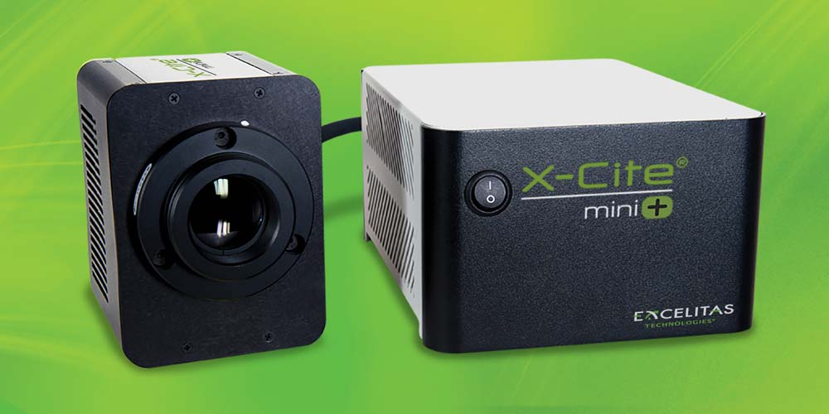
Illustration: The new LED light source provides the output power of higher-end illuminators in a compact, air-cooled and lower-cost system

Additional product improvements and features include:
- Broad spectrum LED output from 360 nm – 700 nm and a choice of 365 nm or 385 nm UV wavelengths. The XTML model features a 385 nm LED, which matches the UV output of its predecessor, for a simple drop-in replacement solution. The XTMS model includes a powerful 365 nm LED compatible with standard narrow DAPI filter sets, making it an ideal replacement for mercury sources.
- Direct coupling to enable a maintenance-free system with no consumables.
- Intuitive manual operation with speedDIAL, foot pedal, USB and TTL control options, compatible with standard X-Cite command set, for seamless integration and convenient control options for any instrument configuration, from basic to fully automated operation.
“The X-Cite mini+ white light LED light source provides clinical, diagnostic and microbiology labs with an economically-priced LED alternative to mercury sources,” said Michelle Gal, senior product manager at Excelitas Technologies. “Delivering more power than its predecessor, X-Cite mini+ provides the output power of higher-end illuminators in a compact, air-cooled and lower-cost system.”

Illustrations: | x-cite_miniplus | Char.s: | 2041
File name: | ENpm_2019_06-20_EXC_x-cite-miniplus | Date: | 06-20-2019
Tags: | 2 - LIG - X-Cite | GPI: | 201906012

About Excelitas Technologies

Excelitas Technologies® Corp. is a global technology leader focused on delivering innovative, high-performance, market-driven photonic solutions to meet the lighting, optronics, detection and optical technology needs of global customers. Serving a vast array of applications across biomedical, scientific, safety, security, consumer products, semiconductor, industrial manufacturing, defense and aerospace sectors, Excelitas Technologies stands committed to enabling our customers' success in their end markets. Excelitas Technologies has approximately 6,700 employees in North America, Europe and Asia, serving customers across the world. Connect with Excelitas on Facebook, LinkedIn and Twitter.

Excelitas® and X-Cite® are registered trademarks of Excelitas Technologies Corp.

Contact:  Excelitas Technologies Corp.  Oliver Neutert  Regional Marketing Manager EMEA  Feldkirchen (near Munich)  Germany  Phone: +49 89-255458-965  Email: oliver.neutert@excelitas.com  Internet: www.excelitas.com | gii die Presse-Agentur GmbH  Immanuelkirchstr. 12  10405 Berlin  Germany  Phone: +49 30-538965-0  Email: info@gii.de  Internet: www.gii.de

