Press Release

12-pole extruder motor

Menzel Elektromotoren has supplied a 12-pole 225-kW motor for a rubber mixing machine. Though this large number of poles is unusual for such a relatively small output, the German motor builder had a suitable unit on stock in its large warehouse. The motor is configured for frequency inverter operation in 60-Hz networks. The rated speed is 710 min⁻¹. This robust motor provides high starting torques and high overload capacities at low speeds. The customer, the global market leader in production of elastomeric insulation systems for thermal and acoustic insulation, needed this motor for a plant in Mexico. To ensure commissioning of the facility on schedule, Menzel adapted the motor in only three and a half weeks. This included a newly engineered and individually welded motor housing that is compatible with the customer’s special coupling and existing foundation interfaces.
More reference projects and inquiries:
https://www.menzel-motors.com/extruder-drive/

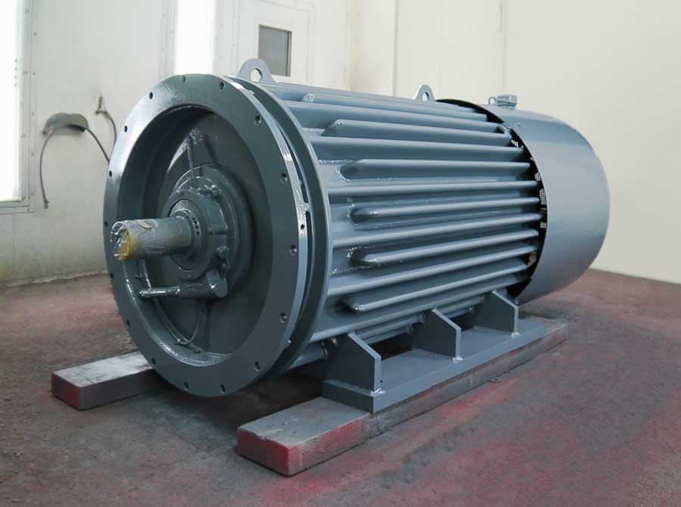
Caption: Menzel’s large motor inventory includes unusual configurations such as this 12-pole medium-power motor

Image/s: | extruder_motor_mexico | Characters: | 882
File name: | 202004021_pm_extruder_motor_mexico_en | Date: | 05-27-2020
About Menzel Elektromotoren
Based in Berlin, Menzel Elektromotoren GmbH has been manufacturing and distributing electric motors for more than 90 years. The medium-sized company specializes in the delivery of large electric motors, including special models, within the shortest possible time. The product range comprises high and low voltage motors, DC motors, transformers, and frequency inverters. Services include motor production and short-term adaptation of stocked motors to application-specific requirements. In order to ensure fast deliveries to the customer at all times, the company maintains a very extensive inventory including more than 20,000 motors with a maximum performance of up to 15,000 kW. Qualified engineering, experienced staff, and state-of-the-art production and testing facilities help Menzel provide excellent reliability. Menzel operates subsidiaries in the UK, France, Italy, Spain, and Sweden, and cooperates with numerous partners worldwide.

Contact:  Menzel Elektromotoren GmbH  Mathis Menzel  Neues Ufer 19-25  10553 Berlin  Germany  Phone: +49 . 30 . 349 922-0  Email: info@menzel-motors.com  Internet: www.menzel-motors.com | gii die Presse-Agentur GmbH  Immanuelkirchstr. 12  10405 Berlin  Germany  Phone: +49 . 30 . 538 965-0  Email: info@gii.de  Internet: www.gii.de

