Press Release

Innovative transformer terminals with push-in connection

CONTA-CLIP expands its range of transformer terminals, adding the innovative PTKS 4 series with push-in connection. Thanks to the tool-free push-in system for connecting rigid wires or wires with end ferrules, the PTKS 4 series simplifies wiring considerably and minimizes the time required. The high contact force of the push-in spring ensures secure fixation of the wire ends even in the event of strong vibrations and mechanical shocks. For convenience, the transformer terminals are terminated from the top, via an integrated pusher that can be operated with light pressure and without any special tools. The terminals are available in 1- or 2-pole versions for 4-mm² wire cross sections. 2- or 3-pole insulated plug-in cross connectors allow for easy potential and power distribution between terminals. Due to their two-part structure of basic clamp and cover, PTKS 4 terminals are well suited for automated soldering processes. After soldering the coil wire, the cover can easily be pushed onto the clamp. The transformer terminal covers can be marked using standard SB 7.5 markers from CONTA-CLIP.

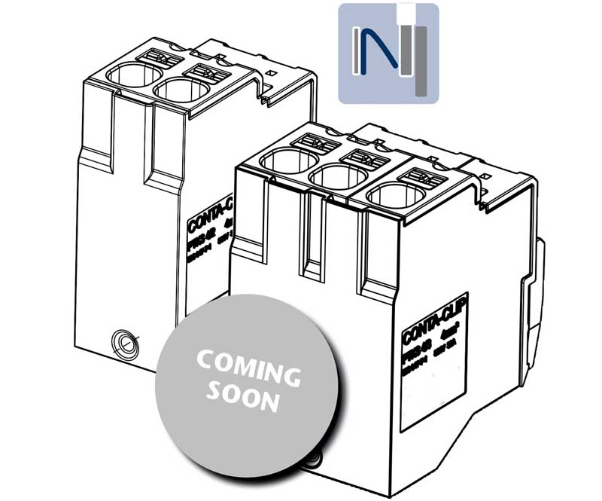
Caption: Innovative concept: New PTKS 4 transformer terminal with push-in connection from CONTA-CLIP

Image/s: | Transformatoren_Klemme_coming_soon | Characters: | 1104
File name: | 202205040_pm_push-in_transformer_terminals_en | Date: | 08-10-2022
About CONTA-CLIP
CONTA-CLIP is one of Europe’s leading manufacturers of electrical and electronic connection elements and cable management solutions. Based in Hövelhof, Germany, the medium-sized, family-run company has been producing electric and electronic connection systems for the process and automation industries since 1978. CONTA-CLIP supplies all industry sectors, focusing on railroad industries, shipbuilding, building automation, conveyor technology, machine and plant engineering and construction, instrumentation and control technology, control panel manufacturing, transformer manufacturing, and environmental technology. The company consists of many specialized branches: CONTA-CONNECT for electric connection technology, CONTA-CABLE for cable management systems, CONTA-ELECTRONICS for electronics and CONTA-CON for PCB edge connectors. Additionally, CONTA-CLIP provides services such as customizing housings and mounting rails, labeling and supplying user-specific electronic components.
Contact:  CONTA-CLIP  Verbindungstechnik GmbH  Franziska Klein  Otto-Hahn-Str. 7  33161 Hövelhof  Germany  Phone: +49 . 5257 . 9833 - 173  Email: franziska.klein@conta-clip.de  Internet: www.conta-clip.com |  | gii die Presse-Agentur GmbH  Immanuelkirchstr. 12  10405 Berlin  Germany  Phone: +49 . 30 . 538 965 - 0  Email: info@gii.de  Internet: www.gii.de

