Press Release

4G-enabled I/O communication modules

Introducing GSM-PRO2 and GSM-PRO2E communication modules, CONTA-CLIP presents economic 4G wireless remote control and maintenance solutions for decentralized applications. If no 4G network is available, the modules automatically fall back on 3G or 2G networks. Users can enhance the GSM-PRO2 module by adding inputs and outputs using I/O extension modules. The basic GSM-PRO2E device features four relay outputs and 10 inputs. I/Os can be configured for digital (24V DC) or analog (0...10V and 0[4]...20mA) signals, as required. The manufacturer supplies suitable models for the European as well as the US market. GSM-PRO modules automatically alert users via text or email messages when the monitored process reaches a defined state or preset limits are exceeded. Control-room staff or service technicians can switch the digital relay outputs of the GSM-PRO2 via text messages. The devices' log functions enable tracking of communications, process values of the analog inputs, and I/O activation events over freely programmable periods of time. Log files can be read out via a USB interface or sent to an email address. Apps for iPhone and Android devices enable fast and easy monitoring and control of the communication modules and allow for a quick overview of all I/O statuses for several modules at once. Parameterization requires no programming skills. Firmware updates and configuration changes can be easily carried out at any time via the GSM network, even after installation and commissioning of the modules.

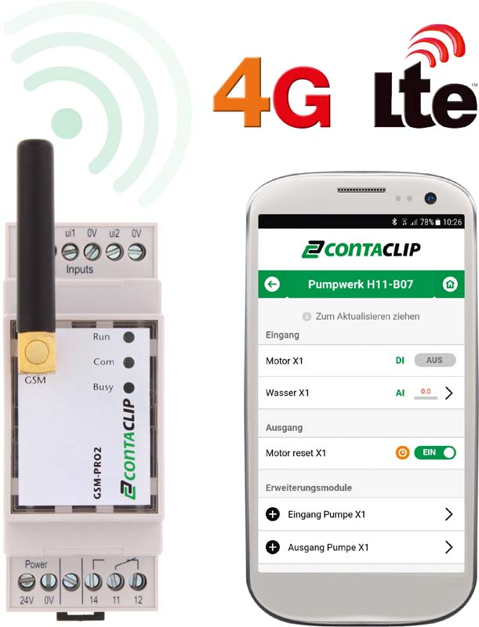
Illustration: The configurable communication modules enable remote control and maintenance via 4G wireless networks

Illustrations: | gsm_pro_4g | Char.s: | 1518
File name: | 201904032_pm_gsm-pro2_4g_en | Date: | 06-12-2019
About CONTA-CLIP
CONTA-CLIP is one of Europe’s leading manufacturers of electrical and electronic connection elements and cable management solutions. Based in Hövelhof, Germany, the medium-sized, family-run company has been producing electric and electronic connection systems for the process and automation industries for 40 years. CONTA-CLIP supplies all industry sectors, focusing on railroad industries, shipbuilding, building automation, conveyor technology, machine and plant engineering and construction, instrumentation and control technology, control panel manufacturing, transformer manufacturing, and environmental technology. The company consists of three specialized branches: CONTA-CONNECT for electric connection technology, CONTA-ELECTRONICS for electronics and CONTA-CON for PCB edge connectors. Additionally, CONTA-CLIP provides services such as customizing housings and mounting rails, labeling and supplying user-specific electronic components.

Contact:  CONTA-CLIP  Verbindungstechnik GmbH  Christian Quade  Otto-Hahn-Str. 7  33161 Hövelhof  Germany  Phone: +49 . 5257 . 9833 - 0  Fax: +49 . 5257 . 9833 - 33  Email: christian.quade@conta-clip.de  Internet: www.conta-clip.com | gii die Presse-Agentur GmbH  Immanuelkirchstr. 12  10405 Berlin  Germany  Phone: +49 . 30 . 538 965 - 0  Fax: +49 . 30 . 538 965 - 29  Email: info@gii.de  Internet: www.gii.de

