Press Release

Despite coronavirus: Large motors ex stock

German motor builder Menzel Elektromotoren keeps a large inventory of motors in stock and is able to fulfill orders even in these times of the coronavirus. The family-run company is the go-to-source when motor failures cause plant standstills or if the usual suppliers cannot maintain delivery dates. Quick shipping of replacement motors has oftentimes prevented production downtimes in the past. Brand-new AC and DC motors are available in various sizes and cooling types: low-voltage motors up to 2500 kW, medium and high-voltage motors up to 15000 kW, AC squirrel-cage and slip ring motors, DC motors up to 600 kW. All these motors comply with the current EN60034, IEC60034, VDE, DIN, and ISO standards. Menzel supplies customers worldwide, adapting the motors individually for each respective customer application. Production and inspection are still being kept up, even now, with staff working two separate shifts and additional measures being taken for maximum protection against infection.
More information and 24/7 inquiries: https://www.menzel-motors.com/article/large-lv-mv-hv-motors/

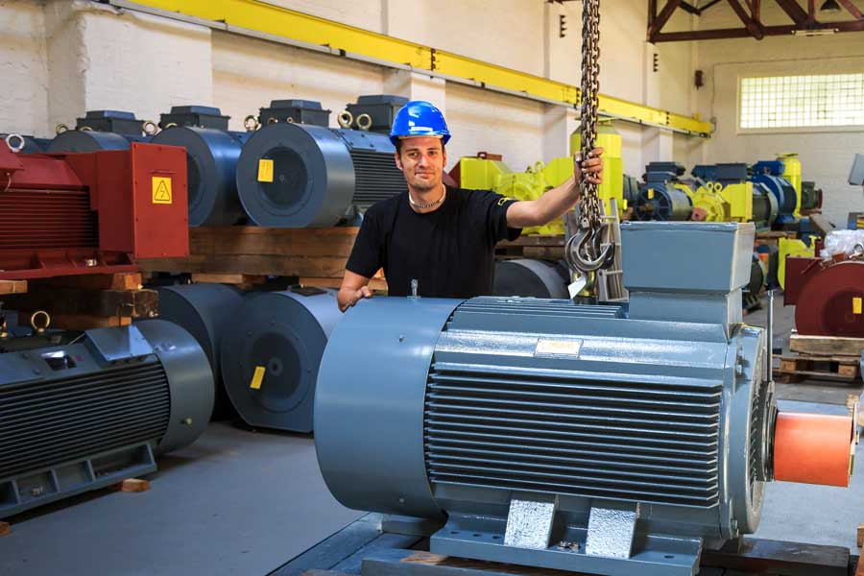
Caption: Berlin-based motor builder Menzel has a huge warehouse with brand-new low, medium, and high-voltage motors up to 15 MW

Image/s: | motors_from_stock | Characters: | 996
File name: | 202003049_pm_motors_ex_stock_en | Date: | 03-30-2020
About Menzel Elektromotoren
Based in Berlin, Menzel Elektromotoren GmbH has been manufacturing and distributing electric motors for more than 90 years. The medium-sized company specializes in the delivery of large electric motors, including special models, within the shortest possible time. The product range comprises high and low voltage motors, DC motors, transformers, and frequency inverters. Services include motor production and short-term adaptation of stocked motors to application-specific requirements. In order to ensure fast deliveries to the customer at all times, the company maintains a very extensive inventory including more than 20,000 motors with a maximum performance of up to 15,000 kW. Qualified engineering, experienced staff, and state-of-the-art production and testing facilities help Menzel provide excellent reliability. Menzel operates subsidiaries in the UK, France, Italy, Spain, and Sweden, and cooperates with numerous partners worldwide.

Contact:  Menzel Elektromotoren GmbH  Mathis Menzel  Neues Ufer 19-25  10553 Berlin  Germany  Phone: +49 . 30 . 349 922-0  Email: info@menzel-motors.com  Internet: www.menzel-motors.com | gii die Presse-Agentur GmbH  Immanuelkirchstr. 12  10405 Berlin  Germany  Phone: +49 . 30 . 538 965-0  Email: info@gii.de  Internet: www.gii.de

