Press Release

Sensor technology expert FSG opens US branch

Berlin – German measuring and sensor technology expert FSG has established its first foreign branch office in the United States. A wholly-owned subsidiary based in Freeport, Maine, FSG Sensors Inc. has started operations in July 2015, providing technical support and supplying FSG products to customers in the US. The branch has a well-stocked inventory. "By establishing our first foreign subsidiary, we are strengthening our position in the US market and are moving closer to our customers," says Managing Director Carsten Schulz. "FSG Sensors Inc. is poised to ensure excellent customer service and readily available support for companies with manufacturing facilities in North America. We can now to meet the increasing demand for our high-quality products and customized solutions much faster." The office will be headed by Robert R. Hornschild-Bear, an American returning home from a long time living in Berlin. Hornschild-Bear has extensive experience in service management.

Contact:

FSG Sensors Inc.
Robert R. Hornschild-Bear
20 Independence Drive, Suite 3B
Freeport ME, 04032 USA
Phone: (207) 480-3173 | 1-800-6444-FSG
Email: sales@fsg-sensors.com
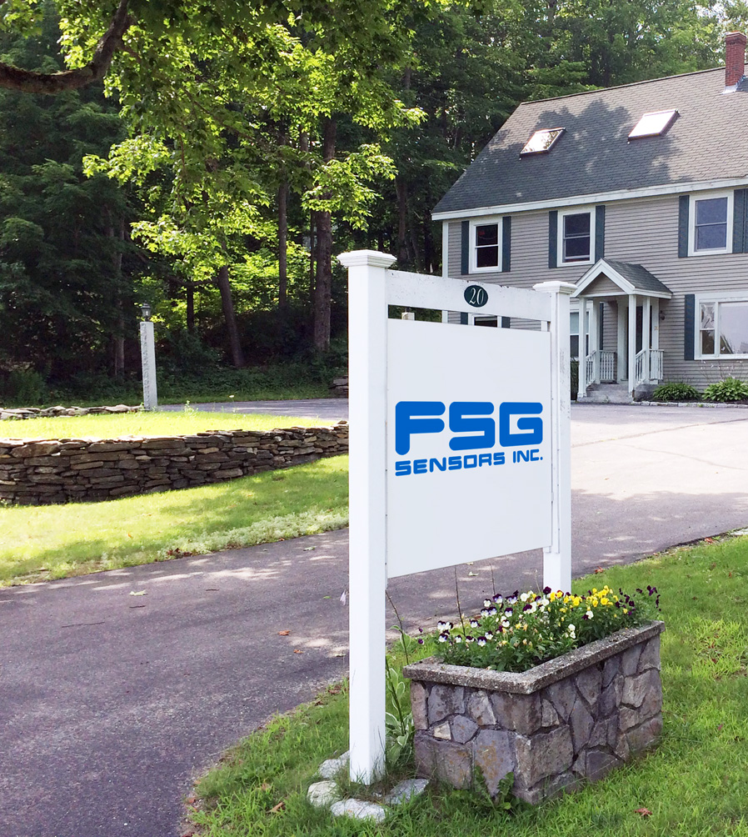
Figure: FSG has opened its first foreign subsidiary in the United States in the summer of 2015.

Figures: | FSG_USA | Char.s: | 1,140
File name: | 201511046_pm_US_niederlassung_en | Date: | 2015-11-19
About FSG
FSG Fernsteuergeräte, a leading supplier of measuring and sensor technology, was founded in 1946. The company develops and manufactures high-quality measuring sensors for automation and safety engineering applications, providing a 95 % depth of production. The product portfolio includes a wide range of customer-oriented systems solutions: linear displacement transmitters, angular position transducers, wind warning systems, manual X/Y control transmitters, pedal actuated transmitters and signal indication components. FSG employs a staff of 350 at its Berlin headquarters and in its Kablow and Heppenheim plants, about 30 % of whom work in research and development, sales and quality management.

Contact:  FSG Fernsteuergeraete  Carsten Schulz  Jahnstr. 68+70  12347 Berlin  Germany  Tel.: +49 30 / 6 29 12 14  Fax: +49 30 / 62 91 52 14  Email: ca.schulz@fernsteuergeraete.de  WWW: www.fernsteuergeraete.de |  | gii die Presse-Agentur GmbH  Immanuelkirchstr. 12  10405 Berlin  Germany  Tel.: +49 30 / 53 89 65-0  Fax: +49 30 / 53 89 65-29  e-mail: info@gii.de  WWW: www.gii.de

