Press Release

Knick Elektronische Messgeräte Launches a New Website
in 2016

Berlin – To start the new year, Knick Elektronische Messgeräte has redesigned its website from the ground up. In redesigning the website, Knick has placed particular emphasis on intuitive, easy-to-navigate and enhanced product and service information. In addition, the full-text search makes quick work of finding the required content or topics.
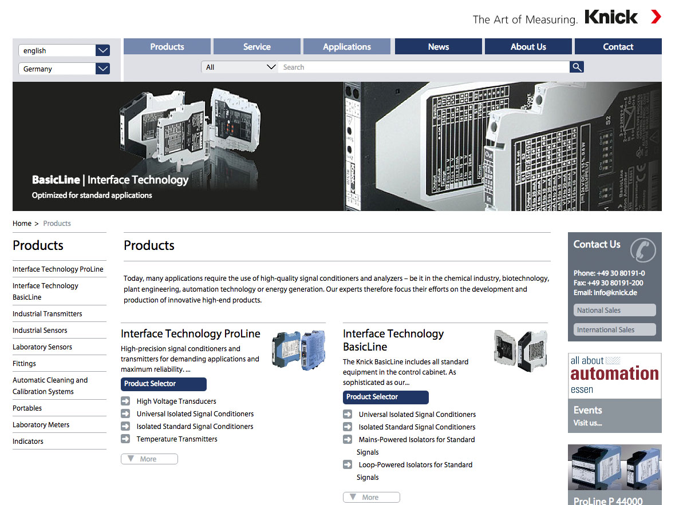
Image: More product information, optimized overview, intuitive navigation:
The new website from Knick Elektronische Messgeräte

The product detail pages have also been restructured. Next to the extensive product-related information, users can now find current links to compatible system components, topic-related areas and training directly. By clicking the adjacent button, users can now call up information on the relevant point of contact for national or international sales. What's more, each product has its own download area with respective user manuals, data sheets and certificates. In addition to numerous new features that assist the user in finding the right product, the leading measurement technology specialist takes into account its increased international activities.
Finally, Knick has significantly expanded two sections of its website: Premium Service customers have their own area and online forms for training registration or repair cases under "Service". The "Applications" section is divided into the "Interface Technology" and "Process Analytics" areas in which the various applications of Knick products in practice are explained.

Figures: | knick-neue-website-en | Char.s: | 1,364
File name: | 201602016_knick_neue_website_en | Date: | 2016-02-10
About Knick
Founded by engineer Ulrich Knick in Berlin more than 70 years ago, Knick Elektronische Messgeräte GmbH & Co. KG still uphold the family company tradition today. The innovative enterprise manufactures measuring and monitoring devices for the chemical industry, system engineering, and industrial automation.

Contact:  Knick Elektronische  Messgeräte GmbH & Co. KG  Carsten Koska  Beuckestr. 22  14163 Berlin  Germany  Tel.: +49 30 / 8 01 91 - 0  Fax: +49 30 / 8 01 91 - 200  e-mail: knick@knick.de  Internet: www.knick.de |  | gii die Presse-Agentur GmbH  Immanuelkirchstr. 12  10405 Berlin  Germany  Tel.: +49 30 / 53 89 65 - 0  Fax: +49 30 / 53 89 65 - 29  e-mail: info@gii.de  Internet: www.gii.de

