Press Release

New wind curtain and pneumatic shutters for camera enclosures

Karlsruhe – Due to a growing demand for camera solutions in dirty environments, autoVimation have expanded their product range. The technology previously proven in the Salamander housing series has been adapted to 3" windows. The new wind curtain now provides a clear view for the larger enclosure series Orca, Mammoth and Chameleon L. Excess dust is blown off the screen by a single blast. Expected deposits or lighter fluid mist can be kept away from the window by a permanent airflow. The wind curtain also helps in high-grade ambient contamination to prolong the cleaning intervals significantly and thus reduce downtime and costs. Even more extreme demands occur in areas where cooling lubricants or wax spray is used, as in machining centers or chassis corrosion protection. An image recording is usually required only before and after the machining, e.g. to verify the position of the workpiece. During the machining process, the front window could be contaminated or even damaged by splashing coolant and chips. The pneumatically driven protective shutter, which opens only during the image acquisition, prevents this. Additionally, a wind curtain can be used to build overpressure and prevent splashes on the windscreen at the moment of opening.

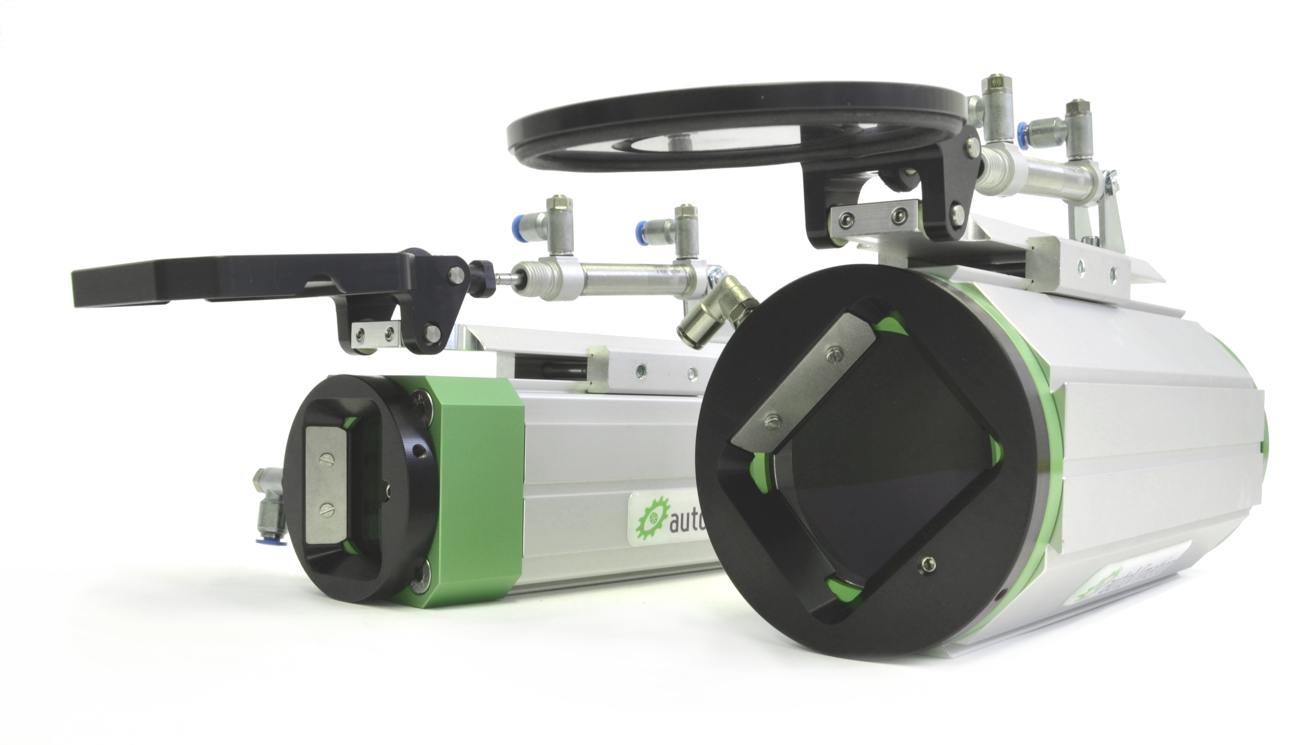
Figure: Wind curtain and pneumatic shutter for 2'' and 3'' windows

Figures: | DSC_0178 | Char.s: | 1,242
File name: | 201604024_pm_3inch_windvorhang_en | Date: | 2016-04-08
About autoVimation
Established in 2008, Karlsruhe-based autoVimation was founded by Peter Neuhaus to provide solutions for easier installation and adjustment of image processing components. The company has developed a modular construction kit that simplifies the connection of all required components, which does away with costly and time-consuming manufacturing of dedicated mounting brackets. The product portfolio also includes compact, easy-to-integrate enclosures that provide optimal protection for cameras and lenses in industrial applications, and ensure good heat dissipation. autoVimation supplies complete, ready-to-install mechanical solutions for cameras and light fittings, and enables the integration of special lenses, filters, light barriers, encoders, or other sensors.
autoVimation's customers include renowned companies from various industry branches, such as the pharmaceutical and food industry, measuring technology, quality control, and security technology.

Contact:  autoVimation GmbH  Peter Neuhaus  Haid-und-Neu-Str. 7  76131 Karlsruhe  Germany  Tel.: +49 721 / 627 6756  Fax: +49 721 / 627 6759  e-mail: sales@autovimation.com  WWW: www.autovimation.com |  | gii die Presse-Agentur GmbH  Immanuelkirchstr. 12  10405 Berlin  Germany  Tel.: +49 30 / 5389 650  Fax: +49 30 / 5389 6529  e-mail: info@gii.de  WWW: www.gii.de

