Press Release

Sun roofs for Salamander and Orca enclosures

Karlsruhe – autoVimation now offers sun roofs for Salamander and Orca enclosures dimensioned for different housing lengths. Conventional CCTV enclosures are oftentimes not suitable for powerful image processing cameras, because of poor heat dissipation. Most devices must not be operated above 50° C camera temperature – yet some models without a protective housing already reach this level at 25° C ambient temperature. In CCTV housing cameras can heat up even more. Installation in a Salamander or Orca housing lowers camera temperature by up to 20° C simply through their excellent passive cooling, allowing for use in hot ambient conditions.
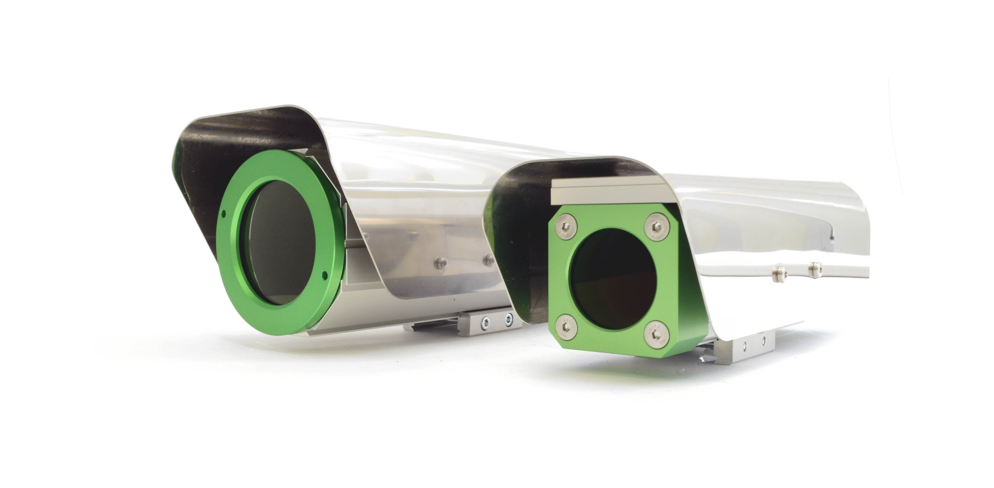
Figure: Salamander and Orca enclosures with new sun roof made from stainless steel

The new solar roofs made from reflective stainless steel now enable operation in direct sunlight as well. because the major part of the heat radiation is reflected. Robust, heat-resistant plastic brackets ensure that the thermal energy is not transmitted from the roof to the protective housing. In addition, the sun roof can be freely positioned longitudinally.
Sufficient space for autoVimation's controlled heating plate remains between roof and housing. This, in combination with the new sun roof, ensures year-round operation of machine vision cameras in temperate climates. For tropical areas autoVimation continues to provide the worldwide proven Turtle housing with active Peltier Cooling.

Figures: | DSC_0192_frei | Char.s: | 1,332
File name: | 201604036_pm_sonnendach_en | Date: | 2016-04-13
About autoVimation
Established in 2008, Karlsruhe-based autoVimation was founded by Peter Neuhaus to provide solutions for easier installation and adjustment of image processing components. The company has developed a modular construction kit that simplifies the connection of all required components, which does away with costly and time-consuming manufacturing of dedicated mounting brackets. The product portfolio also includes compact, easy-to-integrate enclosures that provide optimal protection for cameras and lenses in industrial applications, and ensure good heat dissipation. autoVimation supplies complete, ready-to-install mechanical solutions for cameras and light fittings, and enables the integration of special lenses, filters, light barriers, encoders, or other sensors.
autoVimation's customers include renowned companies from various industry branches, such as the pharmaceutical and food industry, measuring technology, quality control, and security technology.

Contact:  autoVimation GmbH  Peter Neuhaus  Haid-und-Neu-Str. 7  76131 Karlsruhe  Germany  Tel.: +49 721 / 627 6756  Fax: +49 721 / 627 6759  e-mail: sales@autovimation.com  WWW: www.autovimation.com |  | gii die Presse-Agentur GmbH  Immanuelkirchstr. 12  10405 Berlin  Germany  Tel.: +49 30 / 5389 650  Fax: +49 30 / 5389 6529  e-mail: info@gii.de  WWW: www.gii.de

