Press Release

New tilt sensor with shock compensation for a measuring range up to ±60 °

Berlin – Sensor specialist FSG presents new PE-MEMS…/GS70 series tilt angle sensors for monitoring the inclination of construction machinery and measuring tilt angles on ship platforms, working platforms or oil and gas rigs. The two-axis devices feature the proven MEMS technology (micro-electromechanical measuring systems) and ensure high-precision, redundant measurements. An additional gyroscope compensates mechanical shock. GS70 sensors gauge x-axis and y-axis angles in a measuring range of ±60° and achieve accuracies between ±0.05° and ±0.3° depending on angle range. The housing is made from passivated aluminum. The devices are designed for a temperature range between -40 °C and +80 °C and meet all technical safety requirements according to the IEC standards 61508 (SIL 2) and EN 13849 (PLD). GS70 sensors are available for cable connection with IP68 ingress protection or with a plug connector and IP67 ingress protection. A CAN bus interface supports CANopen and the CANopen safety protocol for signal output.

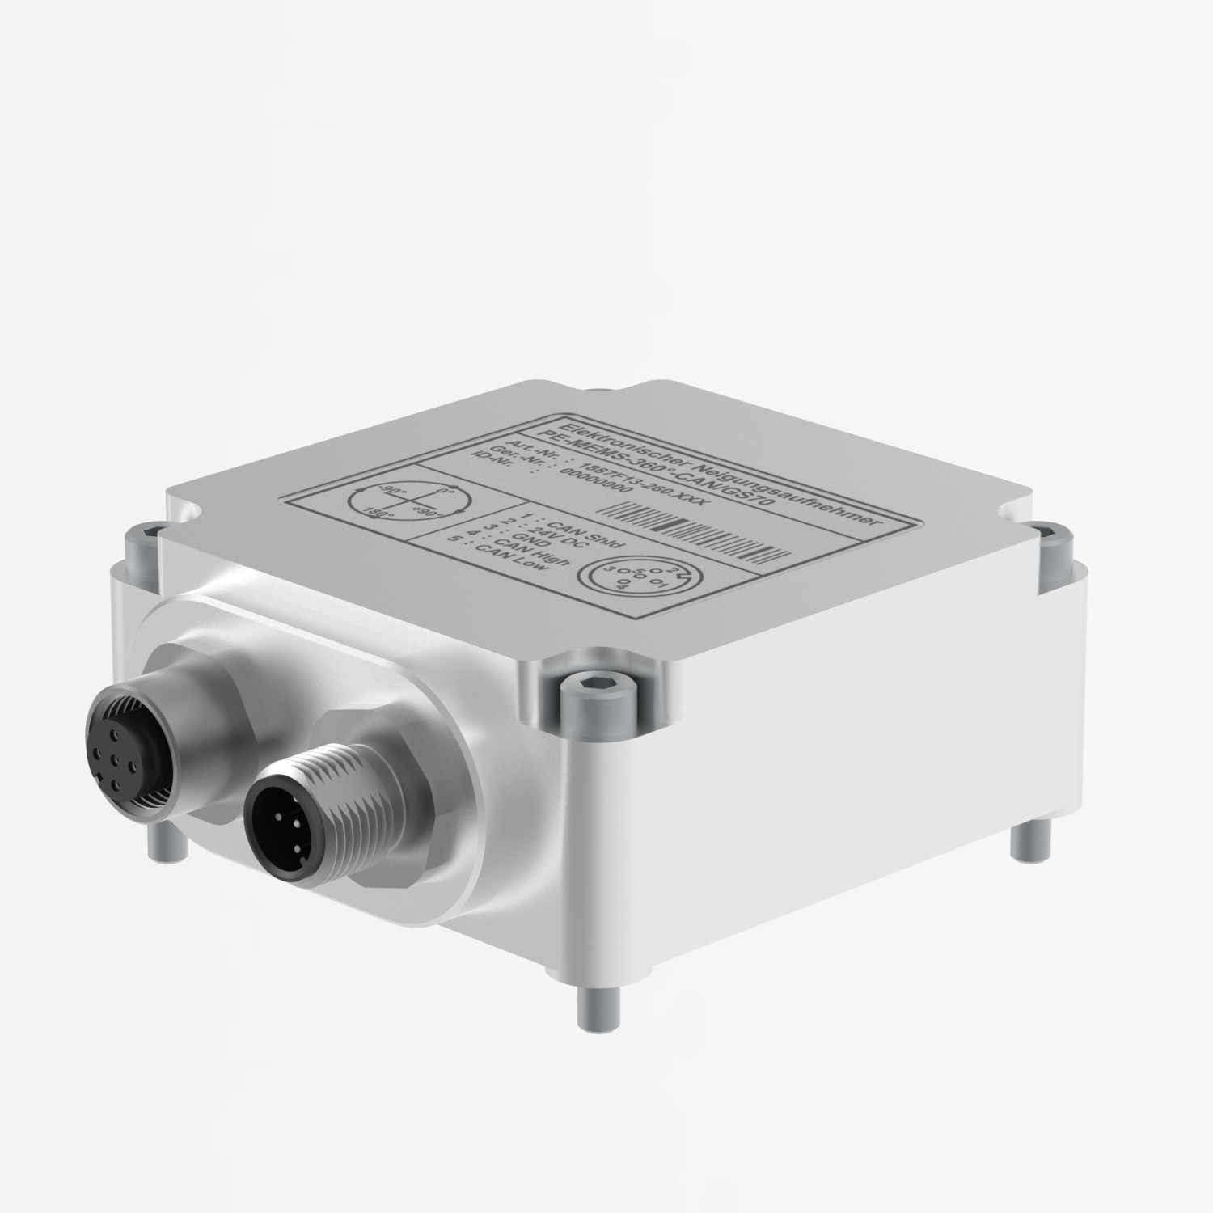
Figure: PE-MEMS…/GS70 series tilt angle sensors from FSG with shock compensation

Figures: | GS70 | Char.s: | 1,016
File name: | 201604066_pm_neigungssensor_GS70_en | Date: | 2016-04-22
About FSG
FSG Fernsteuergeräte, a leading supplier of measuring and sensor technology, was founded in 1946. The company develops and manufactures high-quality measuring sensors for automation and safety engineering applications, providing a 95 % depth of production. The product portfolio includes a wide range of customer-oriented systems solutions: linear displacement transmitters, angular position transducers, wind warning systems, manual X/Y control transmitters, pedal actuated transmitters and signal indication components. FSG employs a staff of 350 at its Berlin headquarters and in its Kablow and Heppenheim plants, about 30 % of whom work in research and development, sales and quality management.

Contact:  FSG Fernsteuergeraete  Carsten Schulz  Jahnstr. 68+70  12347 Berlin  Germany  Tel.: +49 30 / 6 29 12 14  Fax: +49 30 / 62 91 52 14  Email: ca.schulz@fernsteuergeraete.de  WWW: www.fernsteuergeraete.de |  | gii die Presse-Agentur GmbH  Immanuelkirchstr. 12  10405 Berlin  Germany  Tel.: +49 30 / 53 89 65-0  Fax: +49 30 / 53 89 65-29  e-mail: info@gii.de  WWW: www.gii.de

