Press Release

ProLine P50000 from Knick:
Innovative High-Voltage Transducers for Railway Applications

Berlin – Transducers of the new ProLine P50000 series from Knick Elektronische Messgeräte were specially developed for voltage and current measurement in main and auxiliary power circuits of locomotives and multiple units. They are used, for example, for short circuit detection as well as for monitoring of traction motors and inverters, auxiliary inverters and accumulator batteries. The devices comply with all applicable railway standards and thus meet the high demands of fire protection (HL3 according to EN 45545-2 (2016)), electrical safety, mechanical robustness as well as insensitivity to extreme environmental conditions and electromagnetic interferences.
Compared to conventional sensors used in railway vehicles, ProLine P50000 transducers stand out due to their calibrated range selection feature and integrated universal power supply unit. Calibrated range selection allows different input ranges up to ±4200 V to be selected quickly and flexibly. After the switchover, the specified high accuracy (< 0.1 % meas.val. + 0.1 % f.s.) is maintained without readjustment. Combined with a shunt resistor, the device is suitable for precise current measurement up to the kA range. A new, patent-pending design with covered high-voltage terminals ensures contact protection.
Knick offers a 5-year warranty on these high-precision and long-term stable transducers. Learn more at www.knick.de

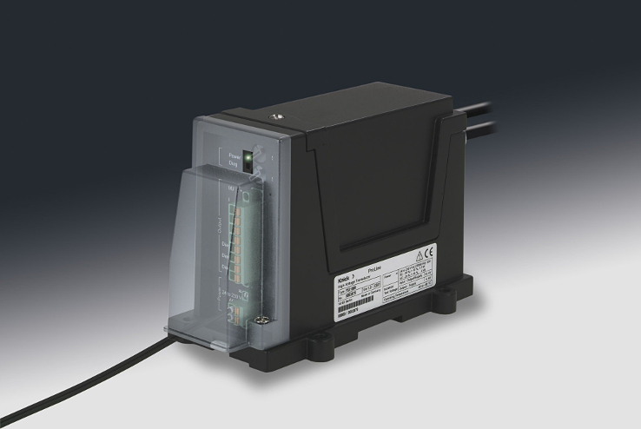
Illustration: Knick ProLine P50000 high-voltage transducers feature
calibrated range selection and an integrated universal power supply

Illustrations: | proline50000 | Char.s: | 1,387
File name: | 201608025_pm_proline_p50000_en | Date: | 2016-08-25
About Knick
Founded by engineer Ulrich Knick in Berlin more than 70 years ago, Knick Elektronische Messgeräte GmbH & Co. KG still uphold the family company tradition today. The innovative enterprise manufactures measuring and monitoring devices for the chemical industry, system engineering, and industrial automation.

Contact:  Knick Elektronische  Messgeräte GmbH & Co. KG  Carsten Koska  Beuckestr. 22  14163 Berlin  Germany  Tel.: +49 . 30 . 80 191-0  Fax: +knick@knick.de  Internet: www.knick.de |  | gii die Presse-Agentur GmbH  Immanuelkirchstr. 12  10405 Berlin  Germany  Tel.: +49 . 30 . 538 965-0  Fax: +49 . 30 . 538 965-29  E-Mail: info@gii.de  Internet: www.gii.de

