Press Release

autoVimation launches new stainless steel enclosure series

Karlsruhe – autoVimation presents the first models of their brand new stainless steel enclosures series at this year’s VISION trade show in Stuttgart. The housings now allow for the protection of cameras with up to 62x62mm cross section – often used within the food industry – from aggressive cleaning agents and high pressure water jets.

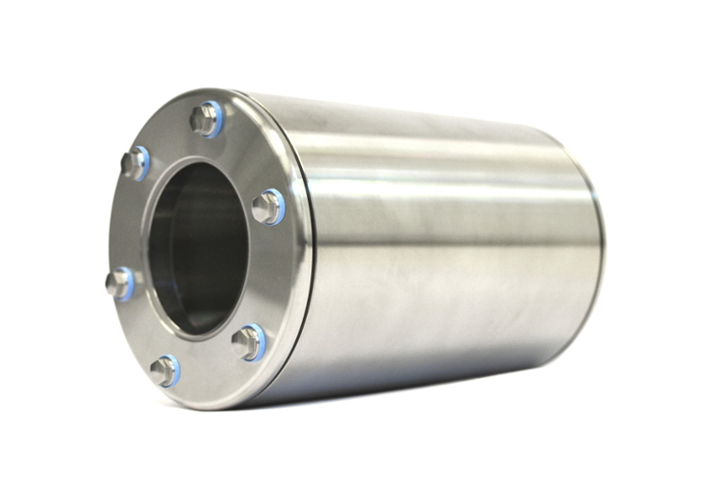
Bild: Stainless steel enclosure in hygienic design and IP69K protection class

Featuring IP69K ingress protection and a consistent hygienic design, the new housings meet all requirements of the food and pharma industry. All new stainless products comply with the highest standards, such as FDA, KTW, EU-Directive EG No. 1935/2004 and EHEDG requirements – thanks to hygienic design measures such as flush mounted windows, using gap-free seals, lack of concave corners, sealing of all touching surfaces and hygienic cable glands and cable conduits.

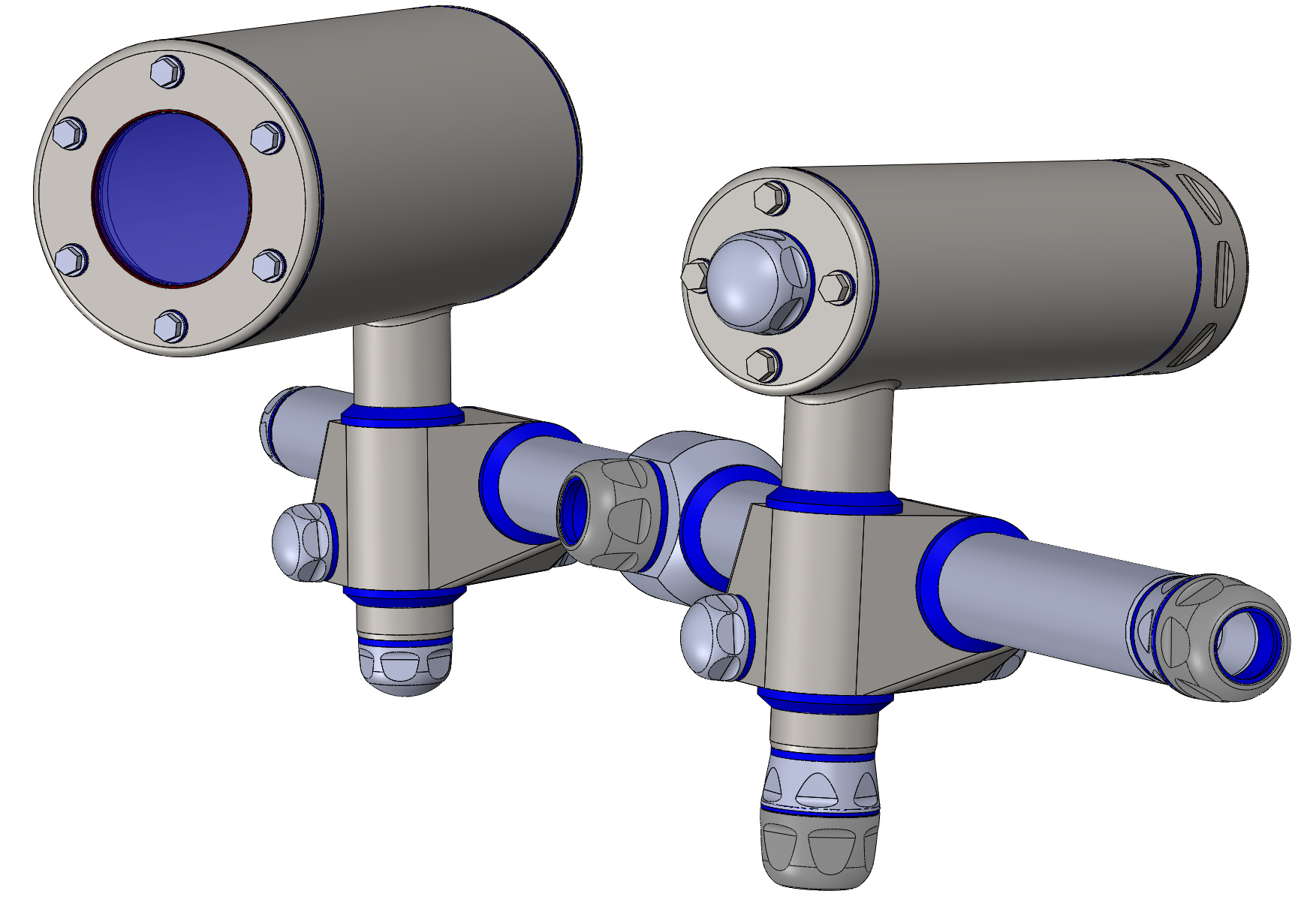
Bild: Stainless steel enclosure with hygienic mounting system

Furthermore, a notable new hygienic mounting solution in stainless steel will be on display. It provides nearly the same flexibility as the established dovetail system from autoVimation. An IP69k laser enclosure in combination with a hygienic triangulation building kit is also in the works. A matching bar light is scheduled to launch in 2017.

Figures: | Orca_stainless_2mod  Hygienedesign | Char.s: | 1,138
File name: | 201610045_pm_edelstahlgehause_en | Date: | 2016-10-24
About autoVimation
Established in 2008, Karlsruhe-based autoVimation was founded by Peter Neuhaus to provide solutions for easier installation and adjustment of image processing components. The company has developed a modular construction kit that simplifies the connection of all required components, which does away with costly and time-consuming manufacturing of dedicated mounting brackets. The product portfolio also includes compact, easy-to-integrate enclosures that provide optimal protection for cameras and lenses in industrial applications, and ensure good heat dissipation. autoVimation supplies complete, ready-to-install mechanical solutions for cameras and light fittings, and enables the integration of special lenses, filters, light barriers, encoders, or other sensors.
autoVimation's customers include renowned companies from various industry branches, such as the pharmaceutical and food industry, measuring technology, quality control, and security technology.

Contact:  autoVimation GmbH  Peter Neuhaus  Haid-und-Neu-Str. 7  76131 Karlsruhe  Germany  Tel.: +49 721 / 627 6756  Fax: +49 721 / 627 6759  e-mail: sales@autovimation.com  WWW: www.autovimation.com |  | gii die Presse-Agentur GmbH  Immanuelkirchstr. 12  10405 Berlin  Germany  Tel.: +49 30 / 5389 650  Fax: +49 30 / 5389 6529  e-mail: info@gii.de  WWW: www.gii.de

