Press Release

New “old” enclosure for the new Flir Ax5 version

Karlsruhe – Due to a modified design, the new version of the Flir Ax5 has significantly larger dimensions. By customizing the Gecko housing, autoVimation has succeeded in accommodating the Ax5 with lenses up to 35mm focal length in this housing type once more. The overall dimensions are a decisive factor for many customers. The larger lenses with 50, 60 and 100mm focal length can be placed in the Orca enclosure with 3" Germanium window.

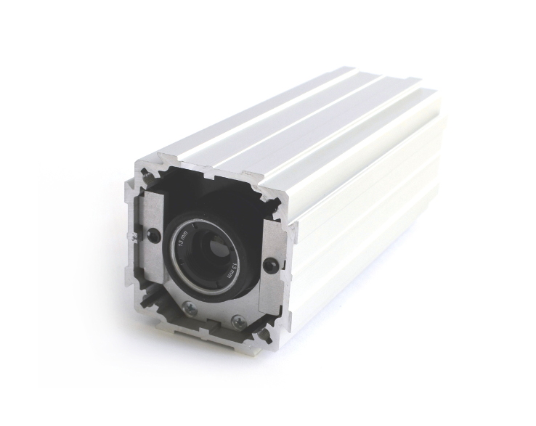
Figure: Modifications allow the larger Flir Ax5 again to be housed in the Gecko enclosure

Figures: | Gecko_neu_Ax5_4_150 | Char.s: | 429
File name: | 201610047_pm_Gecko_Ax5_en | Date: | 2016-10-24
About autoVimation
Established in 2008, Karlsruhe-based autoVimation was founded by Peter Neuhaus to provide solutions for easier installation and adjustment of image processing components. The company has developed a modular construction kit that simplifies the connection of all required components, which does away with costly and time-consuming manufacturing of dedicated mounting brackets. The product portfolio also includes compact, easy-to-integrate enclosures that provide optimal protection for cameras and lenses in industrial applications, and ensure good heat dissipation. autoVimation supplies complete, ready-to-install mechanical solutions for cameras and light fittings, and enables the integration of special lenses, filters, light barriers, encoders, or other sensors.
autoVimation's customers include renowned companies from various industry branches, such as the pharmaceutical and food industry, measuring technology, quality control, and security technology.

Contact:  autoVimation GmbH  Peter Neuhaus  Haid-und-Neu-Str. 7  76131 Karlsruhe  Germany  Tel.: +49 721 / 627 6756  Fax: +49 721 / 627 6759  e-mail: sales@autovimation.com  WWW: www.autovimation.com |  | gii die Presse-Agentur GmbH  Immanuelkirchstr. 12  10405 Berlin  Germany  Tel.: +49 30 / 5389 650  Fax: +49 30 / 5389 6529  e-mail: info@gii.de  WWW: www.gii.de

