Press Release

autoVimation launches innovative LED ring lights

Karlsruhe – autoVimation presents an innovative LED ring light with integrated strobe controller at this year’s Vision trade show in Stuttgart for the first time. The inbuilt micro controller allows for the customization of various parameters such as pulse length, trigger behavior, current amplification and many other settings. Another feature is the opto-isolated wide range trigger input (5-24V). The ring light is programmed via RS232, with Bluetooth and WLAN options to follow soon. The amplification can be regulated to up to 6x nominal current to achieve a maximum power of up to 46W for the eight 1 Watt Oslon LEDs.

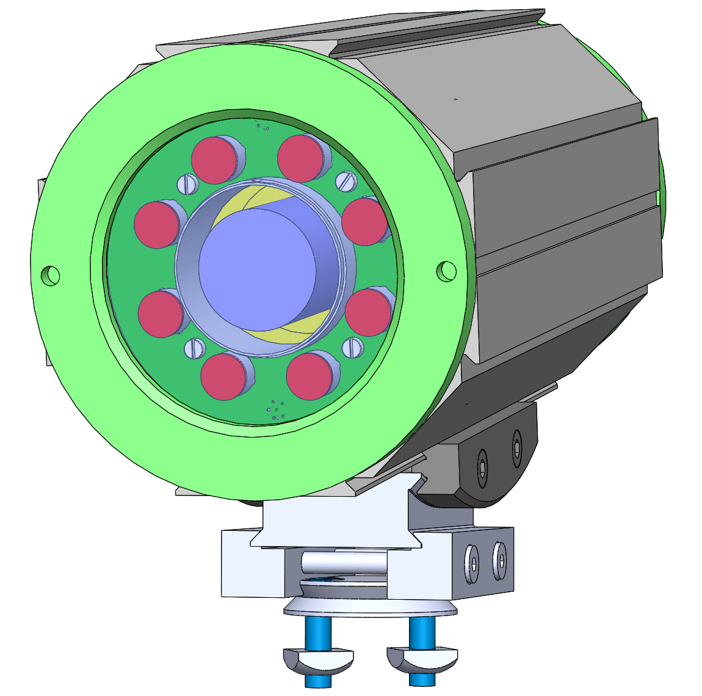
Figure: Orca enclosure with integrated LED ring light

The controller verifies the adjusted settings and gives an alarm in case the current is too high for the pulse length/cycle time ratio. In addition, the controller continuously checks the LED temperature and switches off in case of overheating, with the temperature being transmitted periodically via RS232 (if activated). The integrated strobe controller significantly reduces costs and simplifies cabling – the camera trigger output can be connected directly to the light inside the camera enclosure. Shorter wiring also increases the pulse accuracy by reducing the inductivity of long cables to and from the control cabinet.
The LED ring light fits into the Orca enclosure – the excellent thermal connection to the enclosure passively cools the light. Adding a water cooling system, the enclosure allows greatly increased intensity or strobe length. The ring light is available in typical colors (R, G, B, IR and white). Fan angles can be easily changed by using the proven Lisa2 lenses. Several lights can be strobed and exactly synchronized, triggered by the sync output of the LED master light. A linear IP67 bar light with the same features will be realeased soon, with elements available in ~15cm length and extension options up to 120cm. The single panels with 8 to 46W and a minimal cross section of only 16x40mm feature a very compact form-factor. The bar light is based on the autoVimation double sided dovetail profile and allows for simple positioning and adjusting by using dovetail brackets and mounting kits. It can be combined with other lights, e.G. for dark field illumination from all four sides of the camera image, top lights, light tunnels etc. very easily. Additional passive or water cooling elements can be attached to increase brightness or pulse length up to continuous.

Figures: | Orca_Ringlicht | Char.s: | XXX
File name: | 201610049_pm_ringlicht_en | Date: | 2016-10-24
About autoVimation
Established in 2008, Karlsruhe-based autoVimation was founded by Peter Neuhaus to provide solutions for easier installation and adjustment of image processing components. The company has developed a modular construction kit that simplifies the connection of all required components, which does away with costly and time-consuming manufacturing of dedicated mounting brackets. The product portfolio also includes compact, easy-to-integrate enclosures that provide optimal protection for cameras and lenses in industrial applications, and ensure good heat dissipation. autoVimation supplies complete, ready-to-install mechanical solutions for cameras and light fittings, and enables the integration of special lenses, filters, light barriers, encoders, or other sensors.
autoVimation's customers include renowned companies from various industry branches, such as the pharmaceutical and food industry, measuring technology, quality control, and security technology.

Contact:  autoVimation GmbH  Peter Neuhaus  Haid-und-Neu-Str. 7  76131 Karlsruhe  Germany  Tel.: +49 721 / 627 6756  Fax: +49 721 / 627 6759  e-mail: sales@autovimation.com  WWW: www.autovimation.com |  | gii die Presse-Agentur GmbH  Immanuelkirchstr. 12  10405 Berlin  Germany  Tel.: +49 30 / 5389 650  Fax: +49 30 / 5389 6529  e-mail: info@gii.de  WWW: www.gii.de

