Press Release

autoVimation introduces versatile IP66 stereo vision system

Karlsruhe – The new stereo vision building kit is extended by an electronics box, calculating the stereo image from two USB cameras with FPGA support. The output delivers a depth of field image or point cloud that is transmitted to a PC via Ethernet and processed there. The system works with ambient light, but light sources or pattern projectors can be added if required. Compared with common stereo sensors, users benefit from having full control over the system – the optical base (distance between cameras), camera resolution and lens as well as the working distance may be configured by the customer. The complete set-up is IP66 proof and therefore suitable for wash-down conditions. All that is needed to connect the system, is a LAN and Trigger/Power cable. The stereo vision box can be mounted on the autoVimation dovetail profiles together with the two camera enclosures.

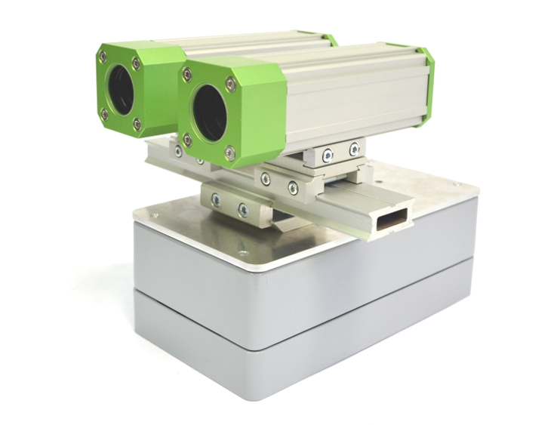
Figure: Flexible Stereo Vision System with IP66 protection

Figures: | Stereo_Vision | Char.s: | XXX
File name: | 201610051_pm_stereo_vision_en | Date: | 2016-10-24
About autoVimation
Established in 2008, Karlsruhe-based autoVimation was founded by Peter Neuhaus to provide solutions for easier installation and adjustment of image processing components. The company has developed a modular construction kit that simplifies the connection of all required components, which does away with costly and time-consuming manufacturing of dedicated mounting brackets. The product portfolio also includes compact, easy-to-integrate enclosures that provide optimal protection for cameras and lenses in industrial applications, and ensure good heat dissipation. autoVimation supplies complete, ready-to-install mechanical solutions for cameras and light fittings, and enables the integration of special lenses, filters, light barriers, encoders, or other sensors.
autoVimation's customers include renowned companies from various industry branches, such as the pharmaceutical and food industry, measuring technology, quality control, and security technology.

Contact:  autoVimation GmbH  Peter Neuhaus  Haid-und-Neu-Str. 7  76131 Karlsruhe  Germany  Tel.: +49 721 / 627 6756  Fax: +49 721 / 627 6759  e-mail: sales@autovimation.com  WWW: www.autovimation.com |  | gii die Presse-Agentur GmbH  Immanuelkirchstr. 12  10405 Berlin  Germany  Tel.: +49 30 / 5389 650  Fax: +49 30 / 5389 6529  e-mail: info@gii.de  WWW: www.gii.de

