Press Release

VariTrans P42000 TRMS: True RMS value measurement for voltages up to 3600 V AC

Berlin, Germany – Knick Elektronische Messgeräte (www.knick.de) is a globally recognized manufacturer of high quality signal, sensor, current and voltage measurement devices for utility, rail, ship, and other rugged environments. With the announcement of their series P42000 TRMS, Knick has defined a completely new class of AC/DC transducers for true RMS values. Input voltages ranging from 10 to 3600 V AC can be safely measured and converted to standard DC analog signals (0…20 mA, 4…20 mA, 0…10 V). These robust transducers are available with up to 16 different I/O settings as well as the capability to be customized with fixed input and outputs for voltages anywhere between 10 and 3.6 kV AC.

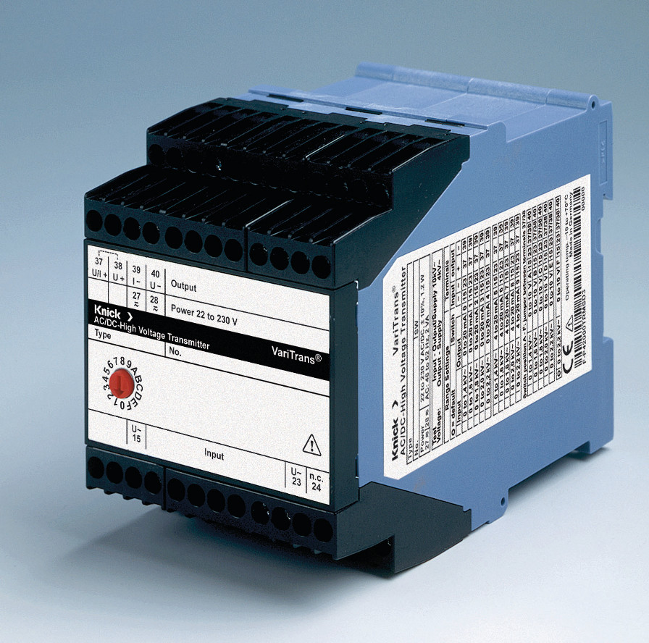
Illustration: AC/DC high voltage transducers are used for measuring the true RMS value of input voltages up to 3600 V.

Thanks to internal TRMS conversion even distorted and non-sinusoidal input signals, that usually cause serious measurement errors, are correctly identified and transmitted. The highly accurate true RMS circuit converts signals with a crest factor of up to 5 with excellent transmission characteristics. With the high insulation properties required for working voltages of up to 3600 V AC and following the safety requirements of EN 61010-1 and EN 50124-1, the design is well suited for harsh conditions, such as the powerful electrical systems on ships, rail, land and military vessels. Internal components are vacuum encapsulated to ensure long-term protection from aggressive environmental influences such as particle ingress and also create mechanical stability for high shock and vibration specifications. Additionally, protective separation of the input, output and power supply provide protection from electric shock up to 1800 V AC/DC according to EN 61140. P42000 TRMS transducers also come with a five-year warranty. For more information, please contact Knick Elektronische Messgeräte at info@knick.de or visit us at www.knick.de

Illustrations: | p42000-trms_3a | Char.s: | 2,147
File name: | 201610055_pm_p42000-trms_en | Date: | 2016-11-30
About Knick
Founded by engineer Ulrich Knick in Berlin more than 70 years ago, Knick Elektronische Messgeräte GmbH & Co. KG still uphold the family company tradition today. The innovative enterprise manufactures measuring and monitoring devices for the chemical industry, system engineering, and industrial automation.

Contact:  Knick Elektronische  Messgeräte GmbH & Co. KG  Carsten Koska  Beuckestraße 22  14163 Berlin  Tel.: +49 30 / 80191 - 0  Fax: +49 30 / 80191 - 200  E-Mail: info@knick.de  Internet: www.knick.de |  | gii die Presse-Agentur GmbH  Immanuelkirchstr. 12  10405 Berlin  Germany  Tel.: +49 . 30 . 538 965-0  Fax: +49 . 30 . 538 965-29  E-Mail: info@gii.de  Internet: www.gii.de

