Press Release

Line of high-temperature ratio pyrometers expanded
Wider temperature range, new application areas

Fluke Process Instruments has added four new single-color and two-color pyrometers to the Endurance series. The series now covers measured temperatures from 50 °C to 3,200 °C. The manufacturer has enhanced the maximum optical resolution from 150:1 to 300:1, enabling measuring of even smaller targets from a distance. A new low-temp ratio pyrometer for demanding applications measures temperatures from 250 °C. The sensors feature galvanically isolated inputs/outputs and a stainless steel IP65 housing.

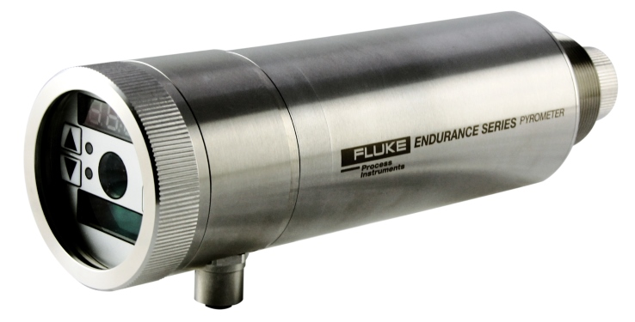
Illustration: New high-precision ratio pyrometers enable continuous visual process monitoring in the harshest industrial environments

They withstand ambient temperatures up to 65 °C or up to 315 °C using cooling accessories. Application areas include primary and secondary metals manufacturing, carbon processing, silicon production, and now also foundries and welding, as well as rubber and thick plastics. The Endurance series offers a versatile range of models with wide temperature ranges and different wavelengths for precise process data that will help manufacturers reduce reject rates, improve product quality and uniformity, maximize throughput, and minimize energy costs. The sensors operate with Power over Ethernet or DC power and interface to Ethernet, ProfiNet, and RS-485. A backlit rear-panel with tactile feedback allows for easy, intuitive navigation. The PC-based Endurance software simplifies configuration and deployment, and a built-in web server enables archiving of historical data for traceability, process troubleshooting and remote viewing. Various lens, sighting, and focus options are available, for example, an on-board camera for video sighting via Ethernet. A dirty lens alarm helps avoid unneeded periodic lens cleaning checks. All Endurance series pyrometers are offered with a best-in-class four-year warranty.

Illustrations: | endurance_ii | Char.s: | 1,714
File name: | 201701013_pm_endurance_new_models_en | Date: | 2017-01-10
About Fluke Process Instruments
Fluke Process Instruments designs, manufactures, and markets a complete line of infrared temperature measurement and profiling solutions for industrial, maintenance, and quality control applications. Distributed worldwide under the Raytek, Ircon, and Datapaq brands, the products reflect the combined experience of over 125 years in manufacturing the world’s finest temperature measurement tools and devices.
About Fluke
Founded in 1948, Fluke Corporation is the world leader in compact, professional electronic test tools. Fluke customers are technicians, engineers, electricians, and metrologists who install, troubleshoot, and manage industrial, electrical, and electronic equipment and calibration processes.

Contact for Europe, Middle East, Africa:  Fluke Process Instruments GmbH  Stephan Wilke  Blankenburger Str. 135  13127 Berlin  Germany  Tel.: +49 . 30 . 478 008 - 0  Fax: +49 . 30 . 471 0251  Email: stephan.wilke@fluke.com  WWW: www.flukeprocessinstruments.com  Contact for Americas, Asia-Pacific:  Fluke Process Instruments  Arlene Lucas-Starrh  Santa Cruz, CA, USA  Tel.: 800 227 8074 (US & Canada)  or +1 831 458 1110  Email: arlene.lucas-starrh@fluke.com |  | gii die Presse-Agentur GmbH  Immanuelkirchstr. 12  10405 Berlin  Germany  Tel.: +49 30 / 53 89 65 - 0  Fax: +49 30 / 53 89 65 - 29  e-mail: info@gii.de  WWW: www.gii.de

