Press Release

Miniature CANopen encoders with redundant Hall sensor

Berlin – Measurement and sensor technology specialists FSG have developed the MH609y-II-CAN series of miniature rotary encoders for limited installation space. They are typically used e.g. for measuring axes in joysticks, command units or driving switches in construction machinery, ships, rail vehicles or other mobile applications. Despite a small diameter of 22.2 mm and a case that is less than 39 mm long, the lightweight encoders (80 g) come with an integrated redundant Hall sensor for detecting 0-360° angles and a CAN-Bus interface.

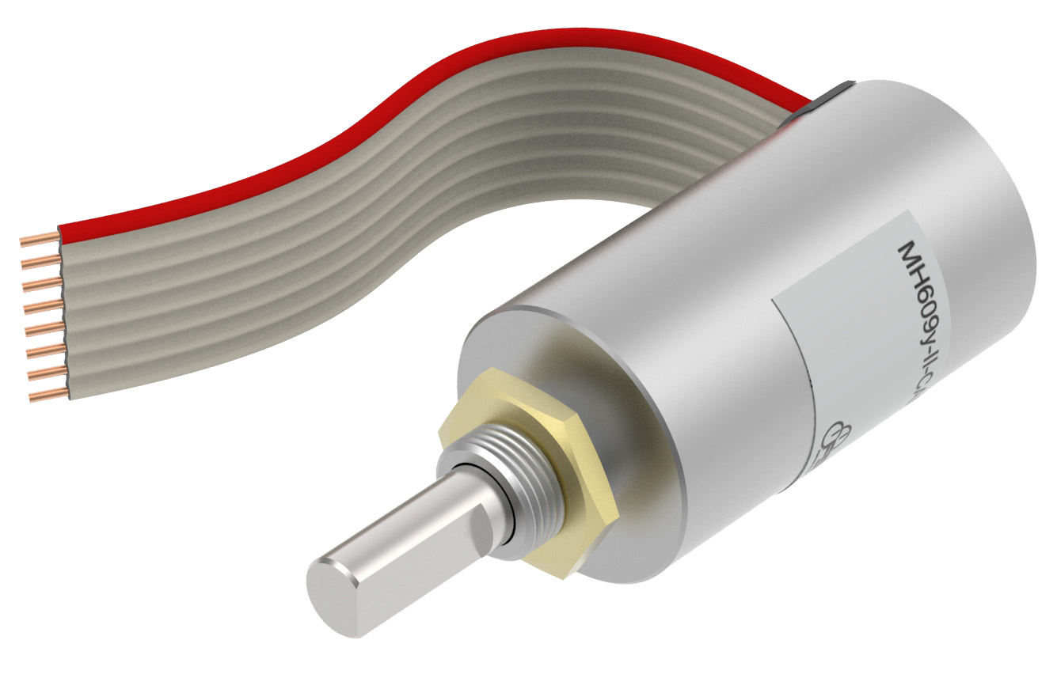
Illustration: MH609y-II-CAN miniature encoder from FSG

Thanks to this dual measurement capability, the encoder is suitable even for safety-relevant applications. The sensor works with a resolution of 12 bit/360° and achieves a linearity of ±0.2% with a repeat accuracy of 0.1°. The CANopen protocol is used for signal output. The encoder is equipped with an 8-pole flat ribbon connection cable and can be installed via M10x0.75 central mounting.
Because the magnetic measuring principle of the Hall sensors requires no mechanical contact, the encoder has a lifespan of at least 300 million cycles. Notably, the miniature encoder is also extremely robust: it features IP65 ingress protection, a housing made of seawater-resistant aluminum and a strong 6 mm shaft made from 1.4305 grade stainless steel. It is suitable for environmental temperatures from -40 °C to +80 °C. It is highly resilient against mechanical impact, with shock and vibration resistance of 25g over 6ms and 4g for 5-100 Hz sine frequencies, respectively. The encoder supports input voltages of 18-36 VDC and draws some 50 mA of current.

Figures: | Miniaturdrehgeber_MH609 | Char.s: | 1.583
File name: | 201701024_pm_miniaturdrehgeber_mh609y-II-can | Date: | 09-18-2018
About FSG
FSG Fernsteuergeräte, a leading supplier of measuring and sensor technology, was founded in 1946. The company develops and manufactures high-quality measuring sensors for automation and safety engineering applications, providing a 90 % depth of production. The product portfolio includes a wide range of customer-oriented system solutions: linear displacement transmitters, angular position transducers, wind warning systems, manual X/Y control transmitters, pedal actuated transmitters and signal indication components. FSG employs a staff of 400 at its Berlin headquarters and in its Kablow and Heppenheim plants, about 30 % of whom work in research and development, sales and quality management.

Contact:  FSG Fernsteuergeraete  Jahnstr. 68+70  12347 Berlin  Germany  Tel.: +49 30 / 6 2 91 1  Fax: +49 30 / 62 91 277  Email: info@fernsteuergeraete.de  WWW: www.fernsteuergeraete.de |  | gii die Presse-Agentur GmbH  Immanuelkirchstr. 12  10405 Berlin  Germany  Tel.: +49 30 / 53 89 65-0  Fax: +49 30 / 53 89 65-29  e-mail: info@gii.de  WWW: www.gii.de

